B11
Handheld Thermal Camera

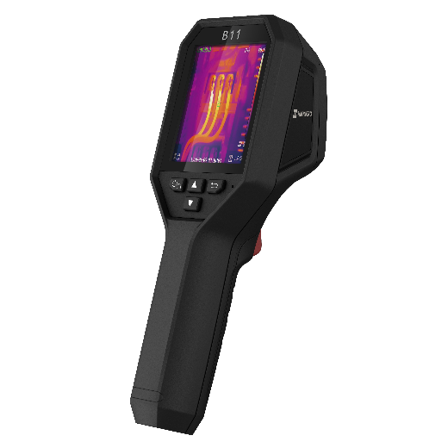
HIKMICRO B11 is designed for temperature measurement to find invisible faults. It’s equipped with a 192 × 144 resolution thermal detector and a 2MP optical detector. The thermography ranges from -20°C to 550°C (-4°F to 1022°F), which meets the most situation. It helps the staff to quickly find the fault according to accurate temperature measurements of high-temperature targets in the environment. Meanwhile, it provides assistance decisions and ensures safety. The device is mainly applied to various industries, such as Building, HVAC, auto industry, etc.

Key Feature
- Thermal resolution: 192 × 144 (27,648 pixels)
- NETD: < 40 mK (@ 25°C, F# = 1.0)
- Temperature measurement range: -20°C to 550°C (-4°F to 1022°F）
- Accuracy: Max (± 2°C/3.6°F, ± 2%), for ambient temperature 15°C to 35°C (59°F to 95°F) and object temperature above 0°C (32°F)
- Measurement presets: Center spot, Hot spot, Cold spot, User Preset Point
- 25 Hz image frequency
- 3.2'' LCD screen display
- Up to 6 hours continuous running

- Specification
Infrared Image
IR Resolution | 192 × 144 (27,648 pixels)
NETD | < 40 mK (@ 25°C, F# = 1.0)
Image Frequency | 25 Hz
Detector Pitch | 12 μm
Spectral Range | 7.5 to 14 μm
Focal Length | 3.6 mm
F-number | F1.0
Field of View (FOV) | 27.8° × 37.2°
Spatial Resolution (IFOV) | 3.3 mrad
Min. Focus Distance | 0.3 m (0.98 ft)
Focus Mode | Focus Free
Image Display
Visual Camera | 1600 × 1200 (2 MP)
Display | 240 × 320 Resolution, 3.2'' LCD Screen
Color Palettes | White Hot, Black Hot, Rainbow, Ironbow
Color Alarm | Above alarm
Image Modes | Thermal/Visual/Fusion/PIP
Measurement and Analysis
Object Temperature Range | -20°C to 550°C (-4°F to 1022°F)
Accuracy | Max. (± 2°C/3.6°F, ± 2%), for ambient temperature 15°C to 35°C (59°F to 95°F) and object temperature above 0°C (32°F)
Measurement Tools | Center Spot, Hot Spot, Cold Spot  User-definable: 3 spots
Level and Span Mode | Auto/Manual
Data Storage and Communication
Storage Media | Built-in 16 GB flash memory
Image Storage Capacity | Approx. 90,000 Images
General
Wi-Fi | 802.11 b/g/n (2.4 GHz)
USB Interface | USB Type-C
LED Light | Yes
Battery Type | Rechargeable Li-ion battery
Battery Operating Time | Approx. 6 hours
Battery Charging Time | Approx. 3 hours fully charged
Protection Level | IP54
Drop Test Height | 2 m (6.56 ft)
Working Temperature Range | -10°C to 50°C (14°F to 122°F)
Storage Temperature Range | -20°C to 60°C (-4°F to 140°F)
Relative Humidity | < 95% non-condensing
Weight | Approx. 380 g (0.84 lb)
Dimension | 221.7 mm × 73.5 mm × 123.8 mm (8.73'' × 2.89'' × 4.87'')
Tripod Mounting | UNC ¼”-20

- Available Model
B11

- Dimension
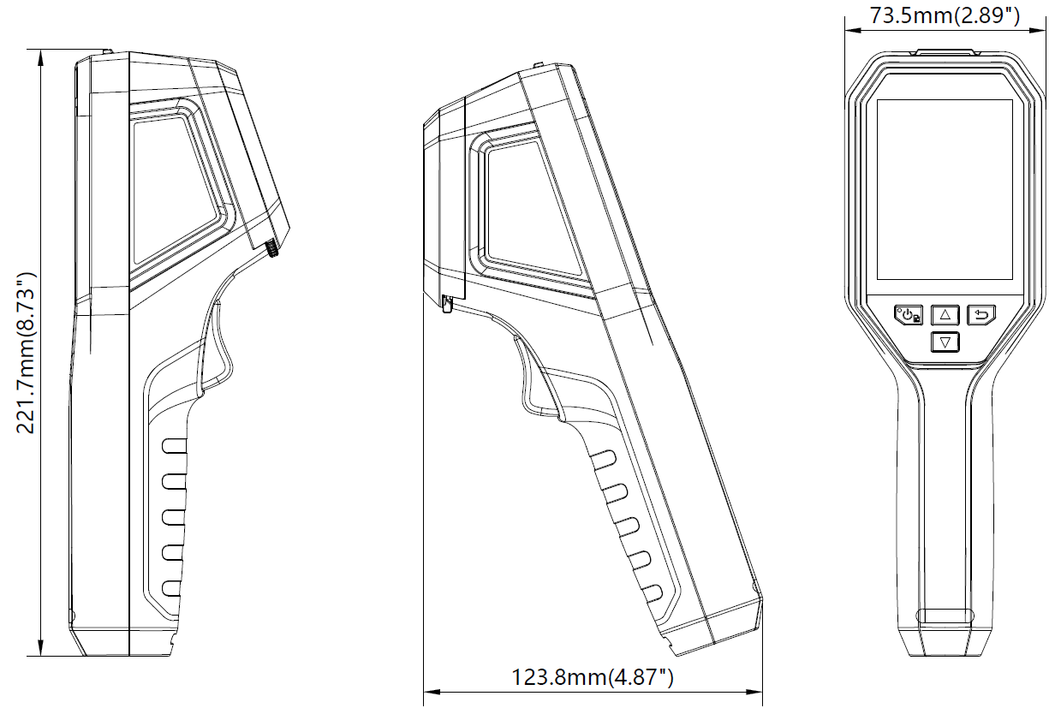

Unit: mm (inch)

- Optional Accessories
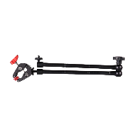 | 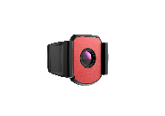 | 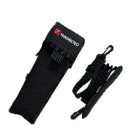
Tripod Mounting Bracket  HM-2925ZJ-TM01-BRACKET | Thermography Camera Macro Lens  HM-B201-MACRO | POUCH  HM-B01-POUCH

COMPLIANCE NOTICE: The thermal series products might be subject to export controls in various countries or regions, including without limitation, the United States, European Union, United Kingdom and/or other member countries of the Wassenaar Arrangement. Please consult your professional legal or compliance expert or local government authorities for any necessary export license requirements if you intend to transfer, export, re-export the thermal series products between different countries.

