B20S
Handheld Thermography Camera

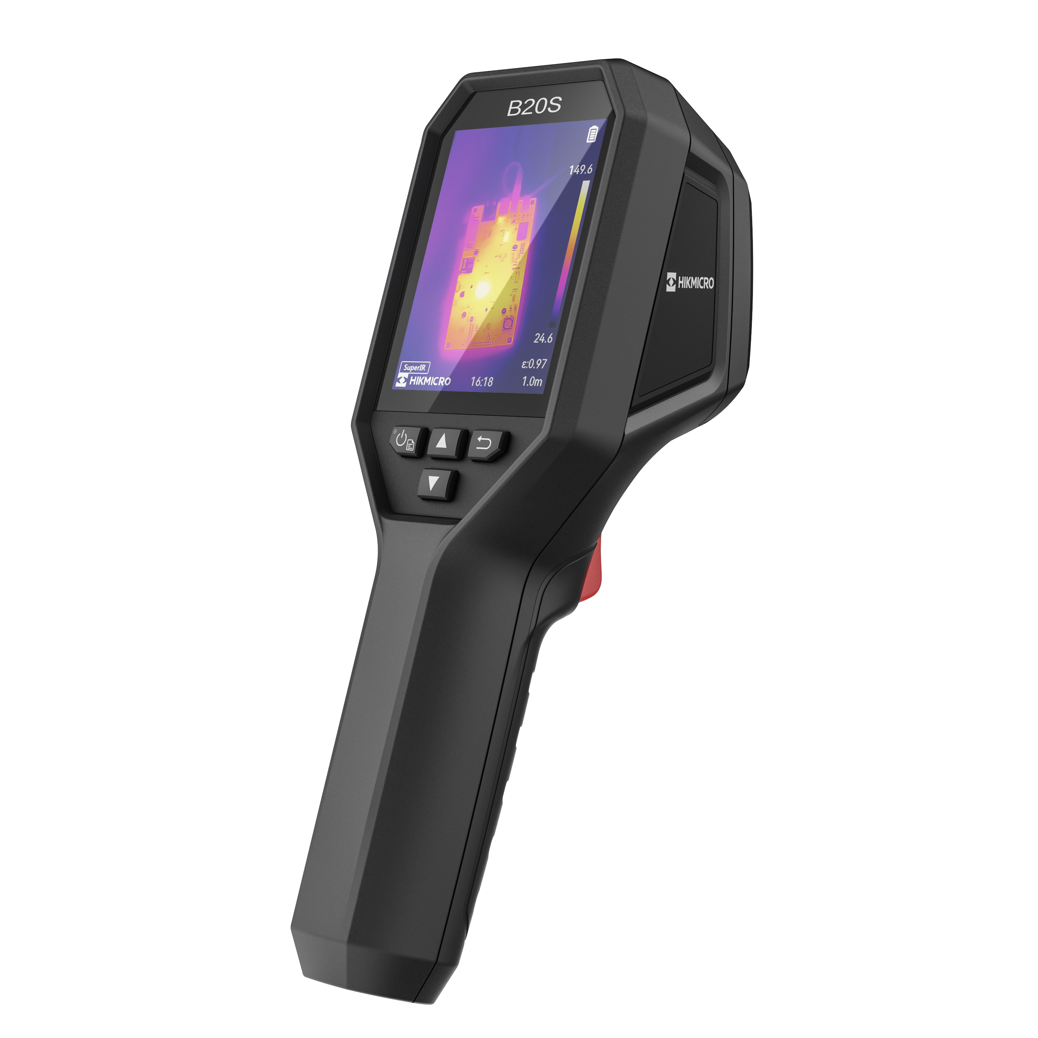

HIKMICRO B20S is designed for temperature measurement to find invisible faults. It’s equipped with a 256 x 192 resolution thermal detector and a 2MP optical detector. The thermography ranges from -20°C to 550°C (-4°F to 1022°F). Which meets most situations. It helps the staff to quickly find the fault according to accurate temperature measurements of high-temperature targets in the environment. Meanwhile, it provides assistance decisions and ensures safety. The device is mainly applied to various industries, such as building, HVAC, and auto industry, etc.
Key Features
- IR resolution: 256 x 192 (49 152 pixels), 2MP Visual Resolution
- Support SuperIR image enhancement technology
- NETD : ＜ 40 mK (@ 25 °C,F#=1.0)
- Temperature measurement range : -20°C to 550°C (-4°F to 1022°F）
- Accuracy: Max (±2°C/3.6°F, ±2%), for ambient temperature 15°C to 35°C (59°F to 95°F) and object temperature above 0°C (32°F)
- Measurement presets: Center spot, Hot spot, Cold spot, User Preset Point
- 25 Hz image frequency
- 3.2" 480 × 640 Resolution LCD Screen
- Up to 6 hours continuous running

- Specification
Infrared Image
IR Resolution | 256 × 192 (49,152 pixels)
SuperIR | Yes, on captured images and live view
NETD | < 40 mK (@ 25 °C, F#=1.0)
Image Frequency | 25 Hz
Detector Pitch | 12 μm
Spectral Range | 7.5 to 14 μm
Focal Length | 3.6 mm
F-number | F1.0
Field of View (FOV) | 37.2° × 50.0°
Spatial Resolution (IFOV) | 3.3 mrad
Min. Focus Distance | 0.3 m (0.98 ft)
Focus Mode | Focus Free
Image Display
Visual Camera | 1600 × 1200 (2 MP)
Display | 480 × 640 Resolution, 3.2" LCD Screen
Color Alarm | Above alarm
Color Palettes | White Hot, Black Hot, Rainbow, Ironbow, Red Hot, Fusion
Image Modes | Thermal/Visual/Fusion/PIP
Measurement and Analysis
Object Temperature Range | -20°C to 550°C (-4°F to 1022°F)
Accuracy | Max. (± 2°C/3.6°F, ± 2%), for ambient temperature 15°C to 35°C (59°F to 95°F) and object temperature above 0°C (32°F)
Measurement Tools | Center Spot, Hot Spot, Cold Spot  User-definable: 3 spots
Level and Span Mode | Auto/Manual
Data Storage and Communication
Storage Media | Built-in 16G eMMC (user available storage space is less than the nominal capacity)
Image Storage Capacity | Approx. 35,000 Images
Image File Format | Radiometric JPEG
General
Wi-Fi | 802.11 b/g/n (2.4GHz)
USB Interface | USB Type-C
LED Light | Yes
Power Supply | USB-C (5V/2A)
Battery Type | Rechargeable Li-ion battery
Battery Operating Time | Approx. 6 hours
Battery Charging Time | Approx. 3 hours fully charged
Protection Level | IP54
Drop Test Height | 2 m (6.56 ft)
Working Temperature Range | -10°C to 50°C (14°F to 122°F)
Storage Temperature Range | -20°C to 60°C (-4°F to 140°F)
Relative Humidity | < 95% non-condensing
Weight | Approx. 380 g (0.84 lb)
Dimension | 221.7 × 73.5 × 123.8mm (8.73 × 2.89 × 4.87 in)
Tripod Mounting | UNC ¼”-20

- Available Model
B20S

- Dimension
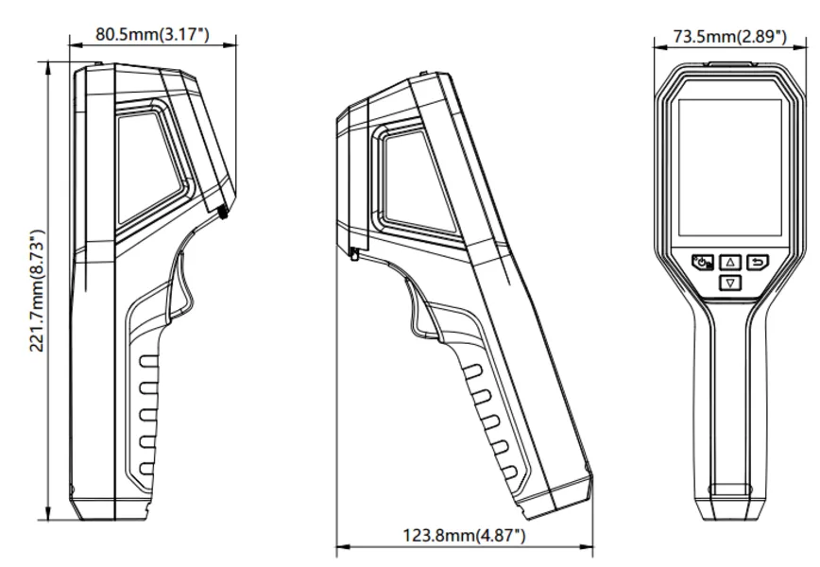

- Optional Accessories
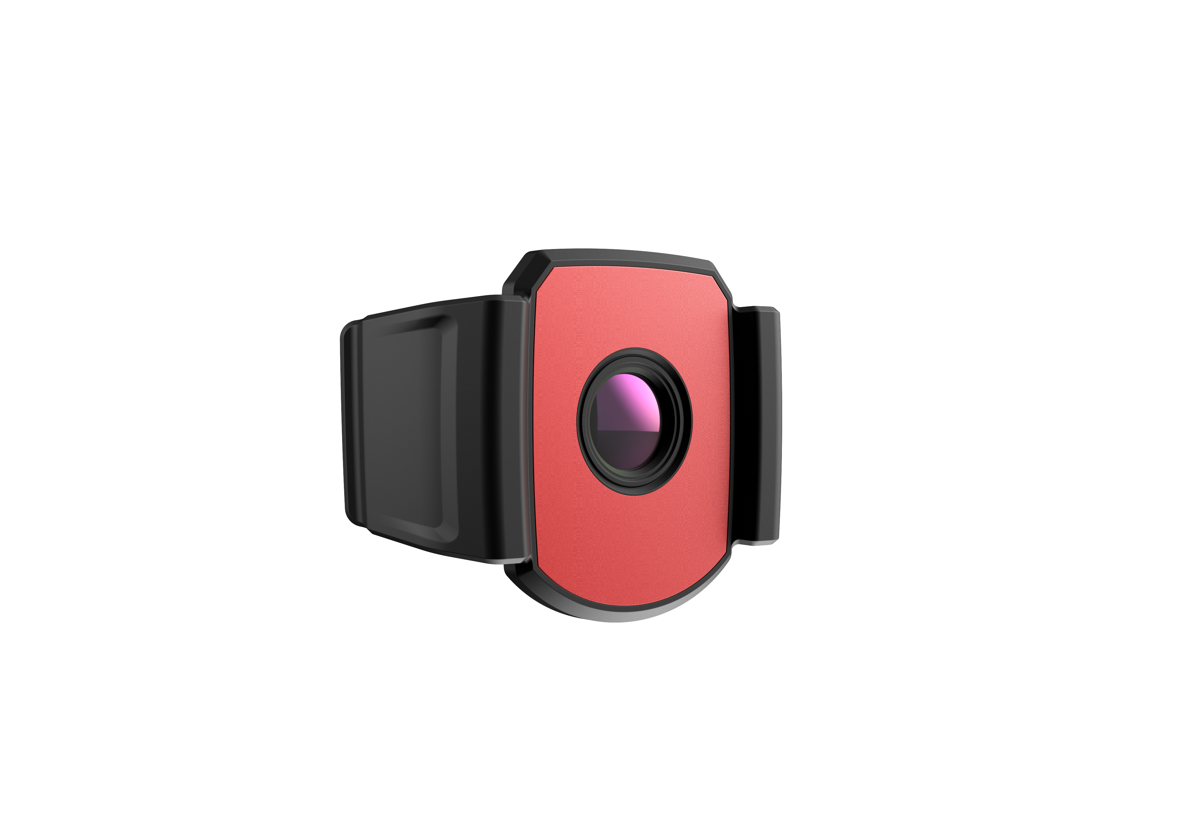 | 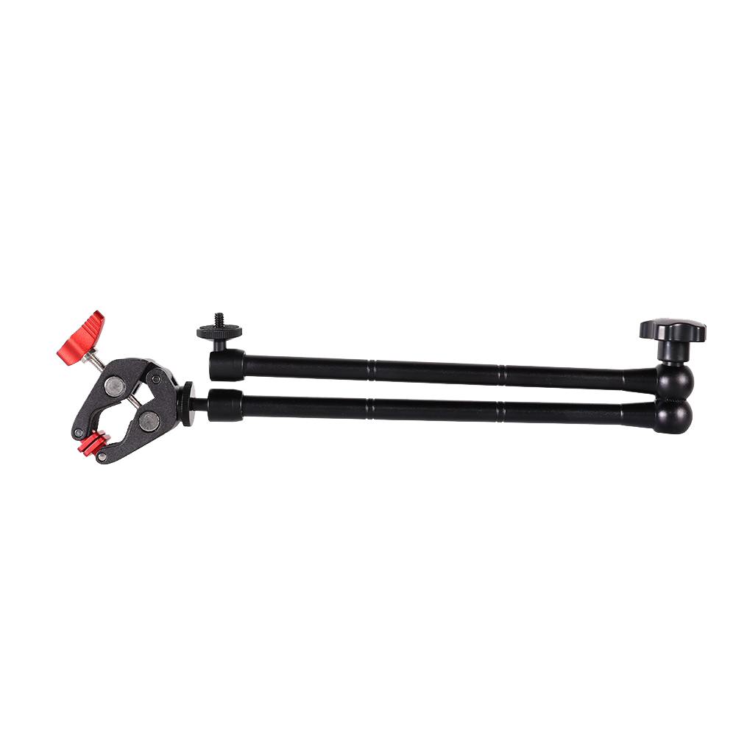 | 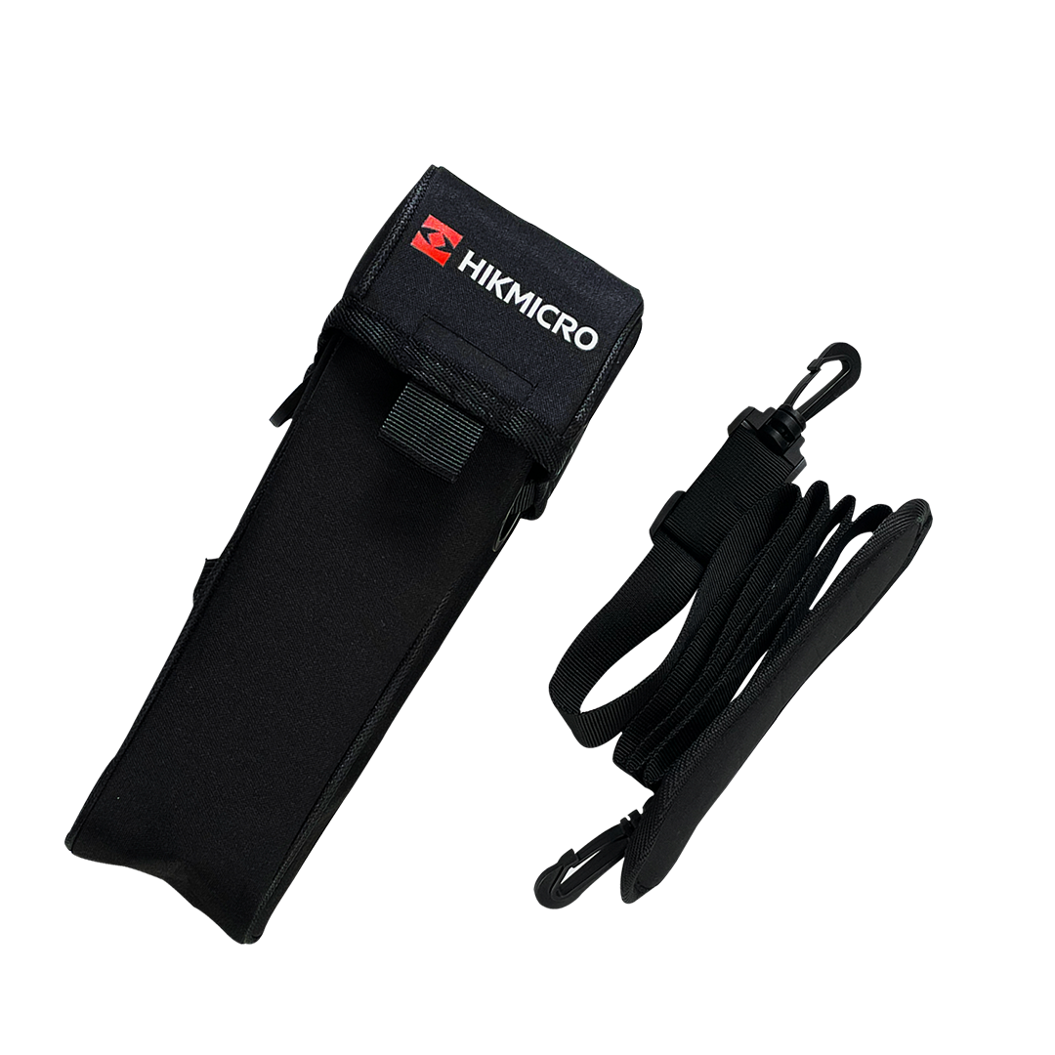
HM-B201-MACRO  Thermography Camera Macro Lens | HM-2925ZJ-TM01-BRACKET  Tripod Mounting Bracket | HM-B01-POUCH  POUCH

COMPLIANCE NOTICE: The thermal series products might be subject to export controls in various countries or regions, including without limitation, the United States, European Union, United Kingdom and/or other member countries of the Wassenaar Arrangement. Please consult your professional legal or compliance expert or local government authorities for any necessary export license requirements if you intend to transfer, export, re-export the thermal series products between different countries.

