FB21
Firefighting Thermal Camera

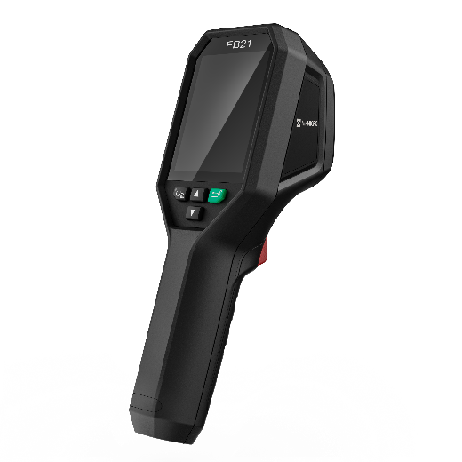

The HIKMICRO FB21 is a compact, reliable, firefighting thermal camera designed for firefighters to observe in total darkness and smoke, helping to save lives, protect property, and keep firefighters safe.
Features like dual cameras, LED flashlights, easy-to-navigate buttons, and a temperature range of up to 550°C (1022°F) help you work effortlessly in harsh environments. 8 color palettes for you to choose from, which satisfy most application scenarios.

Key Feature
- Thermal resolution: 256 x 192 (49 152 pixels)
- NETD : < 40 mK (@ 25 °C, F#=1.0)
- Temperature measurement range : -20°C to 550°C (-4°F to 1022°F）
- Up to 10 minutes for ambient temperature -10°C to 90°C (14°F to 194°F) ; Up to 2 minutes for ambient temperature -10°C to 115°C (14°F to 239°F)
- Measurement presets: Center spot, Hot spot, Cold spot, User Preset Point
- 25 Hz image frequency
- 3.2'' LCD screen display
- Up to 6 hours continuous running
- Support object details enhancement

- Specification
Infrared Image
IR Resolution | 256 × 192 (49,152 pixels)
NETD | < 40 mK (@ 25 °C, F#=1.0)
Image Frequency | 25 Hz
Detector Pitch | 12 μm
Spectral Range | 7.5 to 14 μm
Focal Length | 3.6 mm
F-number | F1.0
Field of View (FOV) | 37.2° × 50.0°
Spatial Resolution (IFOV) | 3.3 mrad
Min. Focus Distance | 0.3 m (0.98 ft)
Focus Mode | Focus Free
Image Display
Visual Camera | 1600 × 1200 (2 MP)
Display | 240 × 320 Resolution, 3.2”LCD Screen
Color Alarm | Above alarm
Color Palettes | Basic, Black Hot, White Hot, Fire Detection, Rescue, Hot Area, Cold Area, Building
Image Modes | Thermal/Visual/Fusion/PIP
Measurement and Analysis
Object Temperature Range | -20°C to 550°C (-4°F to 1022°F)
Accuracy | Max. (± 2°C/3.6°F, ± 2%), for ambient temperature 15°C to 35°C (59°F to 95°F) and object temperature above 0°C (32°F)
Measurement Tools | Center Spot, Hot Spot, Cold Spot  User-definable: 3 spots
Data Storage and Communication
Storage Media | Built-in 16 GB flash memory
Image Storage Capacity | Approx. 90,000 Images
General
USB Interface | USB Type-C
LED Light | Yes
Battery Type | Rechargeable Li-ion battery
Battery Charging Time | Approx. 3 hours fully charged
Battery Operating Time | Approx. 6 hours
Protection Level | IP65
Drop Test Height | 2 m (6.56 ft)
Working Temperature Range | Up to 10 minutes for ambient temperature -10°C to 90°C (14°F to 194°F); up to 2 minutes for ambient temperature -10°C to 115°C (14°F to 239°F)
Storage Temperature Range | -20°C to 60°C (-4°F to 140°F)
Relative Humidity | < 95% non-condensing
Weight | Approx. 380 g (0.84 lb)
Dimension | 221.7 × 73.5 × 123.8 mm (8.73 × 2.89 × 4.87 in)
Tripod Mounting | UNC ¼”-20

- Available Model
FB21

- Dimension
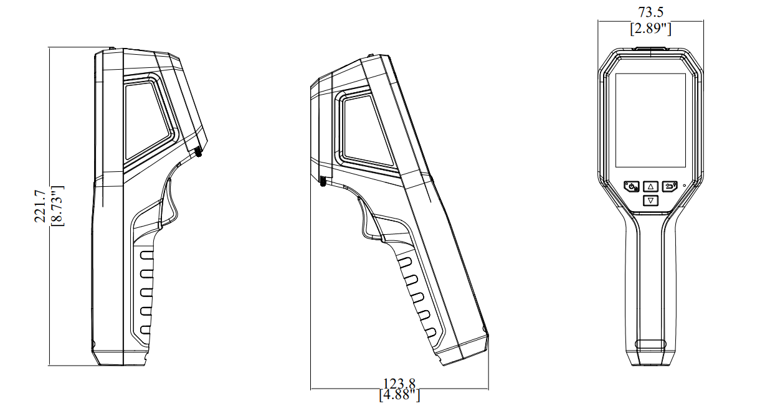
Unit: mm [inch]

COMPLIANCE NOTICE: The thermal series products might be subject to export controls in various countries or regions, including without limitation, the United States, European Union, United Kingdom and/or other member countries of the Wassenaar Arrangement. Please consult your professional legal or compliance expert or local government authorities for any necessary export license requirements if you intend to transfer, export, re-export the thermal series products between different countries.

