FT31
Firefighting Thermal Camera

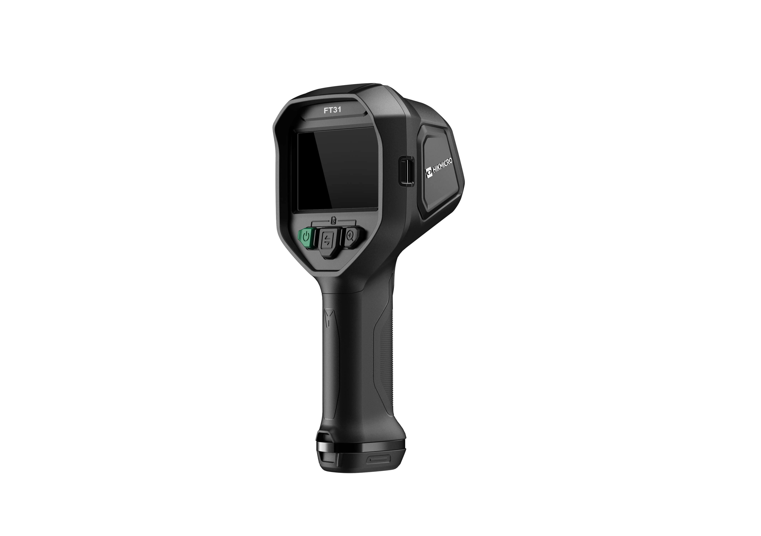

The HIKMICRO FT31 is a high-performance firefighting thermal camera designed for firefighters to observe in total darkness and smoke, helping to save lives, protect property, and keep firefighters safe. Features like object details enhancement, easy-to-navigate buttons and a working temperature range of up to 260°C(500°F) help you work effortlessly in harsh environments. 8 color palettes for you to choose from satisfy most application scenarios.

Key Features
- Thermal resolution: 384 x 288 (110,592 pixels)
- NETD: <35 mK (@ 25°C, F#=1.0)
- Start up time: 5 second (with IR image), 10 second (with OSD)
- Support object details enhancement
- Temperature measurement range : -20°C to 1200°C (-4°F to 2192°F)
- Measurement presets: Center spot, Hot spot, Cold spot
- 60 Hz image frequency
- 4.3" LCD screen display

- Specification
Infrared Image
IR Resolution | 384 x 288 (110,592 pixels)
NETD | <35 mK (@ 25°C, F#=1.0)
Image Frequency | 60 Hz
Detector Pitch | 17 μm
Spectral Range | 7.5 to 14 μm
Focal Length | 7 mm
F-number | F1.6
Field of View (FOV) | 54.1°×40.2°
Spatial Resolution (IFOV) | 2.42 mrad
Min. Focus Distance | 1 m (3.28 ft)
Focus Mode | Focus Free
Image Display
Display | 800 × 480 Resolution, 4.3" LCD Screen
Digital Zoom | 1x, 2x, 4x
Color Palettes | Basic, Black Hot, White Hot, Fire Detection, Rescue, Hot Area, Cold Area, Building
Image Modes | Thermal
Measurement and Analysis
Object Temperature Range | -20°C to 1200°C (-4°F to 2192°F)
Accuracy | Max. (± 2°C/3.6°F, ± 2%), for ambient temperature -20°C to 50°C (-4°F to 122°F) and object temperature above 0°C (32°F)
Measurement Tools | Center Spot, Hot Spot, Cold Spot
Data Storage and Communication
Storage Media | Built-in 32 GB flash memory
Image Storage Capacity | Approx. 100,000 Images
General
USB Interface | USB Type-C
Battery Type | Interchangeable and rechargeable Li-ion battery
Battery Operating Time | Approx. 6 hours
Battery Charging Time | Approx. 3 hours fully charged
Protection Level | IP67, IEC 60529
Drop Test Height | 2 m (6.56 ft), IEC 60068-2-31
Safety | IEC 61010-1
EMC | EN 301 489-1, EN 301 489-17, EN IEC 61000-6-2, EN IEC 61000-6-3
Vibration | 2g IEC 60068-2-6
Shock | 25 g, IEC 60068-2-27
Working Temperature Range | -20°C to 50°C (-4°F to 122°F)  80°C(176°F)，40min  150°C(302°F)，15min  260°C(500°F)，7min
Relative Humidity | < 95% non-condensing
Storage Temperature Range | -20°C to 60°C (-4°F to 140°F)
Weight | Approx. 1022g (2.25 lb)
Dimension | 132.7×276.3×114.6 mm (5.2 × 10.9 × 4.5 in)
Tripod Mounting | UNC ¼”-20

- Available Model
FT31

- Dimension
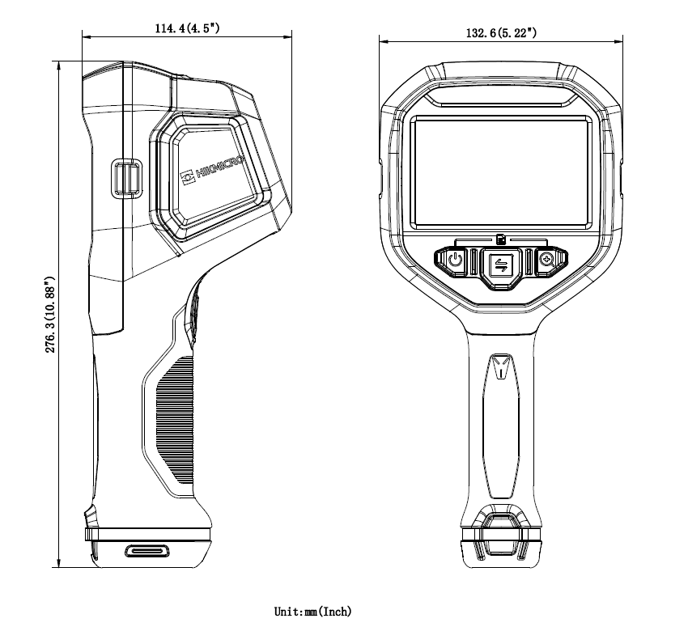
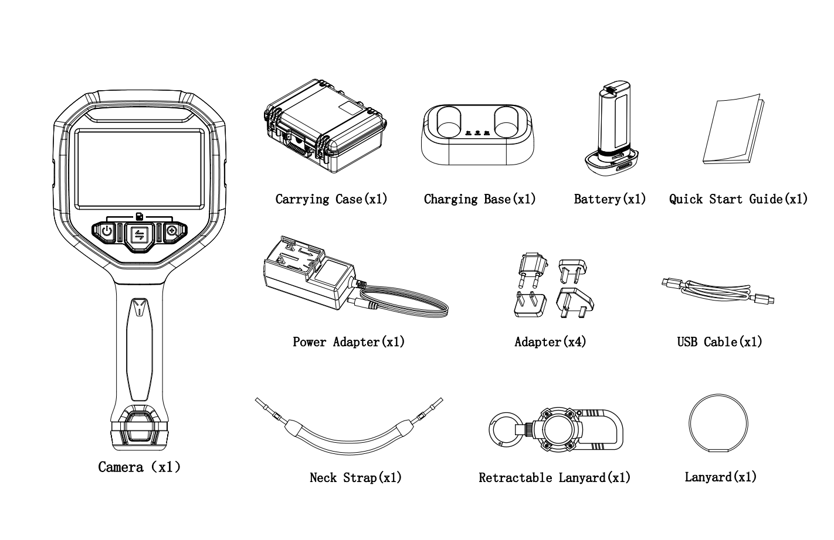

COMPLIANCE NOTICE: The thermal series products might be subject to export controls in various countries or regions, including without limitation, the United States, European Union, United Kingdom and/or other member countries of the Wassenaar Arrangement. Please consult your professional legal or compliance expert or local government authorities for any necessary export license requirements if you intend to transfer, export, re-export the thermal series products between different countries.

