G31
Handheld Thermal Camera

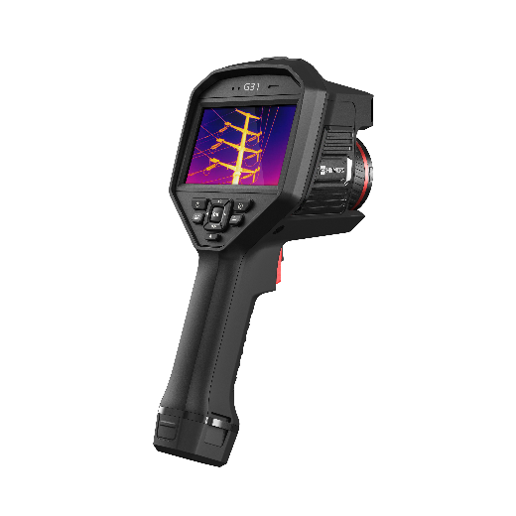

The HIKMICRO G31 high-performance handheld thermal camera is ideal for industrial, predictive, oil and gas, and utility maintenance inspections. HIKMICRO G31 has a high sensitivity (NETD < 35 mK) and high resolution (384 x 288) HIKMICRO VOx detector, and the temperature calibration is up to 650°C. Advanced features help thermal imaging professionals to easily survey equipment and find signs of malfunction, such as GPS and compass annotations, continuous digital zoom, and 1-Tap level and span. Connect HIKMICRO Viewer App or HIKMICRO Analyzer software to transfer, analyze, and share pictures, and generate reports for free.

Key Features
- Thermal resolution: 384 x 288 (110,592 pixels),NETD : ＜ 35 mK (@ 25 °C, F#=1.0)
- Temperature measurement range : -20 °C to 650 °C (-4 °F to 1202 °F)
- Accuracy: Max (±2°C/3.6°F, ±2%)
- 1.x to 8.x continuous digital zoom
- Manual, automatic, and 1-Tap Level and Span
- GPS & compass annotation functions
- Long-distance laser light supplement for thermography targets
- LED light supplement provides light in dark scenarios

- Specification
Infrared Image
IR Resolution | 384 × 288 (110,592 pixels)
SuperIR | 768 × 576 (442,368 pixels)
NETD | < 35 mK (@ 25°C, F# = 1.0)
Image Frequency | 50 Hz
Detector Pitch | 17 μm
Spectral Range | 7.5 to 14 μm
Focal Length | 15 mm
F-number | F1.0
Field of View (FOV) | 25° × 19°
Spatial Resolution (IFOV) | 1.13 mrad
Min. Focus Distance | 0.1 m (0.33 ft)
Focus Mode | Laser Assisted AF/Continuous AF/AF/Manual Focus/Touch AF
Focus Speed | Approx. 2 second
Image Display
Visual Camera | 3264 × 2448 (8 MP)
Display | 800 × 480 Resolution, 4.3" LCD Touch Screen
Screen Brightness | Manual/Auto
Digital Zoom | 1.x to 8.x continuous
Color Palettes | White Hot, Black Hot, Rainbow, Ironbow, Red Hot, Fusion, Rain, Blue Red
Focus Mode Palette | Above/Below/Interval
Color Alarm | Above/Below/Interval/Insulation/Condensation
Image Modes | Infrared/Visual/Fusion/PIP/Blending
Measurement and Analysis
Object Temperature Range | -20 °C to 650 °C (-4 °F to 1202 °F)
Accuracy | Max (±2°C/3.6°F, ±2%)
Measurement Tools | Center Spot, Hot Spot, Cold Spot  User-definable: Delta T, 10 spots, 1 line, 5 rectangles, and 5 circle
Level and Span Mode | Auto/Manual/1-Tap Touch-screen
Inspection Route | Yes
Data Storage and Communication
Storage Media | Removable 64 GB Micro SD Card
Image Storage Capacity | Approx. 60,000 Images
Annotations | Voice note: max. 60 seconds;  Text note: max. 200 characters
Video Storage Capacity | Approx. 54 hours
Video File Format | MP4 video  and radiometric video
Image Format | Radiometric JPEG
Radiometric Infrared-Video Streaming (Compressed) | Over UVC, Wi-Fi
General
Wi-Fi | 802.11 b/g/n (2.4 GHz and 5 GHz)
Bluetooth | Bluetooth 4.2
USB Interface | USB Type-C
HDMI Interface | Yes
LED Light | Yes
Laser Pointer | Yes
Laser | Yes, Class II, Wavelength: 635 nm; Power: < 1 mW
Laser Distance Meter | Indoor distance: 50 m (164 ft);  Outdoor distance: 10 m (33 ft).
Battery Type | Interchangeable and rechargeable Li-ion battery
GPS & Compass | Yes
Battery Operating Time | Approx. 4 hours
Battery Charging Time | Approx. 4 hours fully charged
Power Saving Mode | Yes
Protection Level | IP54, IEC 60529
Drop Test Height | 2 m (6.56 ft), IEC 60068-2-31
Safety | IEC 61010-1
EMC | EN 301 489-1, EN 301 489-17, EN IEC 61000-6-2, EN IEC 61000-6-3, EN IEC 61326-1, EN IEC 61326-2-2
Vibration | 2 g, IEC 60068-2-6
Shock | 25 g, IEC 60068-2-27
Storage Temperature Range | -20°C to 60°C ( -4°F to 140°F)
Working Temperature Range | -20°C to 50°C ( -4°F to 122°F)
Relative Humidity | < 95% non-condensing
Weight | Approx. 1058 g (2.33 lb)
Dimension | 284.7 × 120.6 × 124.5 mm (11.21 × 4.75 × 4.9 in)
Tripod Mounting | UNC ¼”-20

- Available Model
HM-TP73-15SVF/W-G31

- Dimension
- 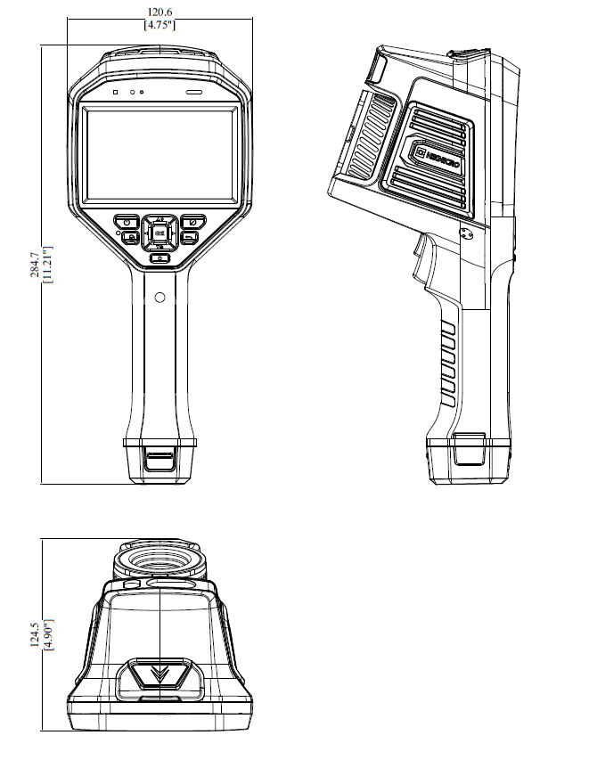
Unit: mm [inch]

- Optional Accessories

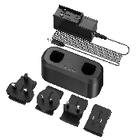  HM-5202ZC2  G Series Charging Base | 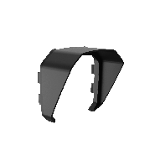  HM-701ZJ-G01-SHIELD  Handheld Thermography Accessory | 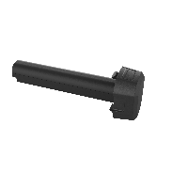 INR18650-35E-1S2P  G Series Battery | 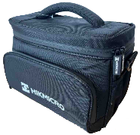  HM-SP01-POUCH  M/G/SP Series Pouch | 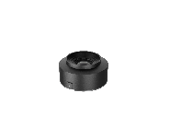  HM-G305-LENS1  0.5x wide angle lens, for G31
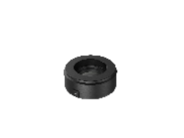  HM-G320-LENS1  2x telephoto lens, for G31 | 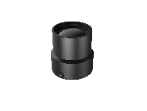  HM-G330-LENS1  3x telephoto lens, for G31

COMPLIANCE NOTICE: The thermal series products might be subject to export controls in various countries or regions, including without limitation, the United States, European Union, United Kingdom and/or other member countries of the Wassenaar Arrangement. Please consult your professional legal or compliance expert or local government authorities for any necessary export license requirements if you intend to transfer, export, re-export the thermal series products between different countries.

