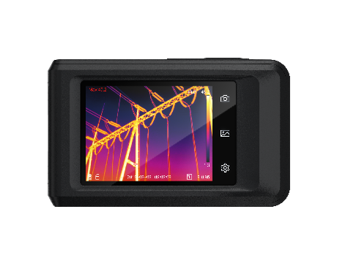

HM-TP42-3AQF/W-Pocket2
Pocket Thermography Camera

HIKMICRO Pocket Series is equipped with a high-resolution HIKMICRO VOx detector, an 8 MP optical camera, and a 3.5” LCD touch screen. It helps you quickly and efficiently locate the hidden problems and accurately measure abnormal temperature. The wide temperature range of -20°C to 400°C is ideal for building inspection, HVAC, electrical, and mechanical equipment maintenance. The 25 Hz frame rate keeps up with fast inspections, and the Wi-Fi function allows the Pocket to share images in real time. The Pocket Series is a powerful thermography tool in your pocket, so it is always there whenever you need it.



- Thermal resolution: 256 × 192 (49,152 pixels), NETD: < 40 mK (@ 25°C, F# = 1.0)
- Accurately measure temperature from -20°C to 400°C (-4°F to 752°F)
- Accuracy: Max. (± 2°C/3.6°F, ± 2%)
- 25 Hz image frequency
- Thermal, fusion, PIP, and optical modes, 8 MP Optical camera
- Manual, automatic, and 1-Tap level and span
- High temperature alarm
- Built-in 16 GB memory
- LED work light
- 1.0x to 4.0x continuous digital zoom
- Up to 4 hours continuous running



Thermal Module
IR Resolution | 256 × 192 (49, 152 pixels)
Spectral Range | 8 to 14 μm
NETD | < 0.04°C (40 mK) at 25°C (77°F) ambient temperature, F# = 1.0
Focal Length | 3.5 mm
Focus | Fixed
FOV (Field of View) | 50° H × 37.2° V
IFOV (Spatial Resolution) | 3.43 mrad
Image Frequency | 25 Hz
Min. Focusing Distance | 0.3 m (0.98 ft)
Detector Type | Vanadium Oxide Uncooled Focal Plane Array
Detector Pitch | 12 μm
F-number | F1.1
optical Module
FOV (Field of View) | 64.6° H × 51.5° V
Picture Resolution | Configurable: 2 MP, 5 MP, 8 MP
Video Resolution | 640 × 480
Focus | Fixed
Built-in Visual Camera | 3264 × 2448 (8 MP)
image display
Level/ Span | Auto/Manual/1-Tap Touch-screen
Display | 640 × 480 Resolution, 3.5” LCD Touch Screen
Image Modes | Thermal/Optical/Fusion/PIP
Color Palettes | 7: White Hot, Black Hot, Rainbow, Ironbow, Red Hot, Fusion, Rain
Fusion | Thermal image with visual camera details
Digital Zoom | 1.0x to 4.0x continuous
PIP | Resizable and movable infrared area on the visual image
Screen Brightness | Manual adjustment
Minimum Temp Span (Manual) | 2°C (3.6°F)
measurement and analysis
Object Temperature Range | -20°C to 400°C ( -4°F to 752°F )
Accuracy | Max. (± 2°C/3.6°F, ± 2%), for ambient temperature from 15°C to 35°C (59°F to 95°F) and object temperature above 0°C (32°F)
Measurement Presets | Center Spot, Hot Spot, Cold Spot, Off
High Temperature Alarm | Audible/visual alarm of above temperature threshold, user-defined temperature threshold
On-Camera Emissivity Correction | Variable from 0.01 to 1.0 or selected from the materials list
On-Camera Reflected Temperature Compensation | Automatic, based on the input of the reflected temperature
On-Camera Transmission Correction | Automatic, based on the inputs for distance and humidity
storage
Storage Media | Built-in EMMC (16 GB)
Image Storage Capacity | Approx. 60,000 images
Image File Format | Radiometric.JPEG with measurement data included  Thermal.THM.JPEG without measurement data included
Video Storage Capacity | Approx. 10 h
Video File Format | Standard MP4 non-radiometric video
Text Note | Max. 200 Characters
power system
Power Supply | 5 VDC/2 A (Charging via USB), fast charging
Power Consumption | 1.92 W
Battery Type | Rechargeable Li-ion battery
Battery Operating Time | 4 hours continuous running per battery (actual life varies depending on settings and usage)
Battery Charging Time | 1.5 h to 94%, 2.5h to full charge
Battery Charging System | In-imager charging, fast charging
AC operation | AC operation with included power supply (100 VAC to 240 VAC, 50/60 Hz)
General
Wi-Fi | 802.11 b/g/n (2.4 GHz, 5 GHz)
Bluetooth | Bluetooth 4.2
USB Interface | USB 2.0, USB Type-C
LED light (torch) | Yes
Microphone | Yes
Buzzer | Yes, audible alarm of above temperature threshold
Carrying pouch | Yes
Warranty | 3 years for whole product, 10 years for detector, and 2 years for battery
Recommended calibration cycle | 1 year (Assumes normal operation and normal aging)
Safety | IEC 62368-1: Overvoltage category II, Pollution Degree 2
Language | 21 Languages  English, German, French, Spanish (Spain), Portuguese (Portugal), Italian, Czech, Slovak, Polish, Hungarian, Romanian, Dutch, Danish, Norwegian, Finnish, Swedish, Russian, Turkish, Japanese, Korean, Chinese (Traditional)
Working Temperature Range | -10°C to 50°C (14°F to 122°F)
Protection level | IP54 (protected against dust, limited ingress; protection against water spray from all directions)
Drop Test Height | 2 m (6.56 ft)
Weight | Approx. 218 g (0.481 lb)
Dimension | 138.5 mm × 85.2 mm × 23.6 mm (5.45” × 3.35” × 0.93”)
Storage Temperature Range | -20°C to 60°C (-4°F to 140°F)
Tripod Mounting | UNC ¼”-20
Relative Humidity | < 95% non-condensing
Electromagnetic compatibility | EN55032: 2015+A11: 2020  EN50130-4: 2011+A1: 2014  EN61000-3-3: 2013
Australian RCM | EN 61010-1: 2010  EN55032: 2015+A11: 2020  EN50130-4: 2011+A1: 2014  EN61000-3-3: 2013
US FCC | CFR 47, Part 15 Subpart B
RoHS compliant | Yes
Vibration | 0.03 g2/Hz (3.8 g), 2.5 g IEC 60068-2-6
Shock | 25 g, IEC 68-2-29
software
PC Software | HIKMICRO Analyzer
APP | HIKMICRO Viewer App
Cast Screen | UVC Alarm Client


HM-TP42-3AQF/W-Pocket2


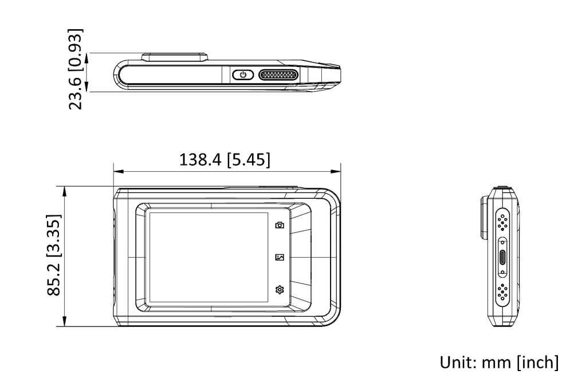


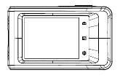  Camera (× 1) |   Quick Start Guide (× 1) | Power Supply (× 1) |  | 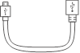  USB Cable (× 1)
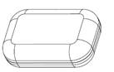 Carrying Pouch (× 1) |   Wrist Strap (× 1)

COMPLIANCE NOTICE: The thermal series products might be subject to export controls in various countries or regions, including without limitation, the United States, European Union, United Kingdom and/or other member countries of the Wassenaar Arrangement. Please consult your professional legal or compliance expert or local government authorities for any necessary export license requirements if you intend to transfer, export, re-export the thermal series products between different countries.

