M31
Handheld Thermography Camera

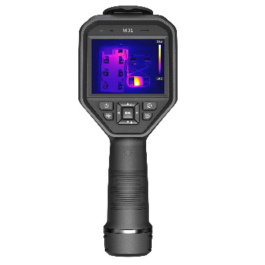
HIKMICRO M31 handheld camera is specially designed for temperature measurement. It’s equipped with a 384 x 288 resolution thermal detector. It helps the staff to quickly find the high-temperature targets in the environment. Meanwhile, it provides assistance with decisions and ensures safety. The device is mainly applied to various industries, such as Building, HVAC, auto industry, etc.

- Features
- High sensitivity thermal module with 384 x 288 resolution
- Leading thermal image processing technology: Adaptive AGC, DDE, 3D DNR
- Supports multiple palettes
- High quality optical module with 8 MP resolution
- Bi-spectrum image fusion, picture-in-picture preview
- Wide temperature measurement range: -20℃~650℃
- High temperature measurement accuracy: Up to ±2° C, ±2%
- 640 x 480 resolution 3.5'' LCD touch display
- Long-distance laser light supplement for thermography targets
- LED light supplement makes the device a torch in required scenarios
- Supports 1.0x to 8.0x continuous digital zoom

- Specification
Infrared Image
IR Resolution | 384 x 288 (110,592 pixels)
SuperIR | 768 x 576 (442,368 pixels)
NETD | < 30mK (@ 25 °C, F#=1.0)
Image Frequency | 50Hz
Detector Pitch | 17 μm
Spectral Range | 7.5 to 14 μm
Focal Length | 6.4mm
F-number | F1.0
Field of View (FOV) | 41.1°×30.5°
Spatial Resolution (IFOV) | 1.87 mrad
Min. Focus Distance | 0.1 m (0.32ft)
Focus Mode | Manual Focus
Image Display
Visual Camera | 3264 × 2448 (8 MP)
Display | 640 × 480 Resolution, 3.5" LCD Touch Screen
Screen Brightness | Manual
Digital Zoom | 1.0x to 8.0x continuous
Color Palettes | White Hot, Black Hot, Rainbow, Ironbow, Red Hot, Fusion, Rain, Blue Red
Focus Mode Palette | Above/Below/Interval
Color Alarm | Above/Below/Interval/Insulation
Image Modes | Thermal/Visual/Fusion/PIP/Blending
Measurement and Analysis
Object Temperature Range | -20 °C to 650 °C (-4 °F to 1202 °F)
Accuracy | Max (±2°C/3.6°F, ±2%), for the ambient temp. 15°C to 35°C (59°F to 95°F) and object temp. above 0°C (32°F)
Measurement Tools | Center Spot, Hot Spot, Cold Spot  User-definable: 10 spots, 1 line, 5 rectangles, and 5 circles
Level and Span Mode | Auto/Manual/1-Tap Touch-screen
Data Storage and Communication
Storage Media | Removable 64 GB Micro SD Card
Image Storage Capacity | Approx. 100,000 Images
Annotations | Voice note: max. 60 seconds;  Text note: max. 200 characters
Video Storage Capacity | Approx. 300 hours
Video File Format | MP4 video  and radiometric video
General
Wi-Fi | 802.11 b/g/n (2.4 GHz and 5 GHz)
Bluetooth | Bluetooth 4.2
USB Interface | USB Type-C
LED Light | Yes
Laser | Yes, Class II, Wavelength: 635 nm; Power: < 1 mW
Battery Type | Interchangeable and rechargeable Li-ion battery
Battery Operating Time | Approx. 4 hours
Battery Charging Time | Approx. 4 hours fully charged
Power Saving Mode | Yes
Protection Level | IP54
Drop Test Height | 2 m (6.56 ft)
Safety | IEC 61010-1
EMC | EN 50130-4, EN 55032, EN IEC 61000-3-2, EN 61000-3-3
Vibration | 2g, IEC 60068-2-6
Shock | 25g, IEC 60068-2-27
Working Temperature Range | -20°C to 50°C (-4°F to 122°F)
Storage Temperature Range | -40°C to 70°C (-40°F to 158°F)
Relative Humidity | < 95% non-condensing
Weight | Approx. 720g (1.59 lb)
Dimension | 244 × 100 × 104 mm (9.6 × 3.9 × 4.1 in)
Tripod Mounting | UNC ¼”-20

- Available Model
HM-TP23-7QF/W-M31

- Dimension
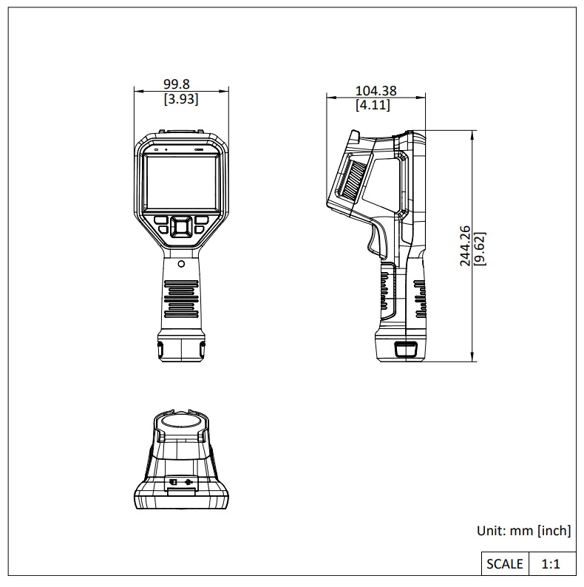

- Packaging List
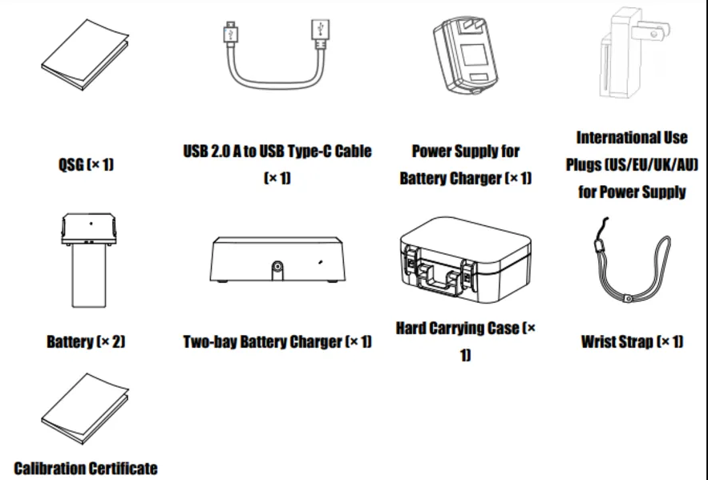

- Accessory
- Optional
E097-13-1S1P26650  M Series Battery | HM-5202ZC  M Series Charging Base | HM-2925ZJ-TM01-BRACKET  Tripod Mounting Bracket | HM-SP01-POUCH  M/G/SP Series Pouch
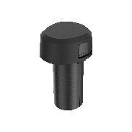 | 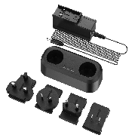 | 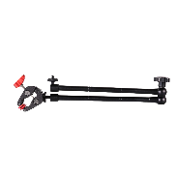 | 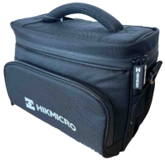

COMPLIANCE NOTICE: The thermal series products might be subject to export controls in various countries or regions, including without limitation, the United States, European Union, United Kingdom and/or other member countries of the Wassenaar Arrangement. Please consult your professional legal or compliance expert or local government authorities for any necessary export license requirements if you intend to transfer, export, re-export the thermal series products between different countries.

