M60
Handheld Thermography Camera

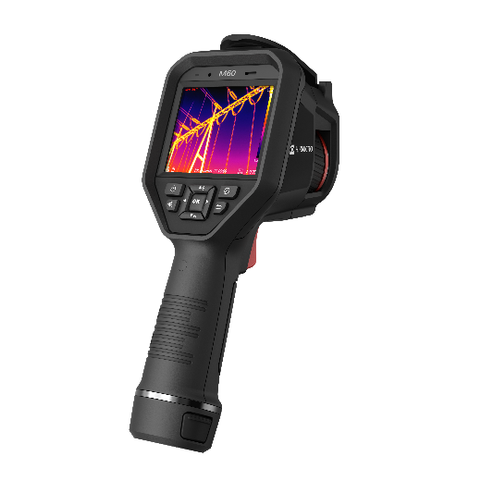

HIKMICRO M60 handheld camera is specially designed for temperature measurement. It’s equipped with a 640 × 480 resolution thermal detector. It helps the staff to quickly find the high-temperature targets in the environment. Meanwhile, it provides assistance with decisions and ensures safety. The device is mainly applied to various industries, such as Building, HVAC, auto industry, etc.
Key Feature
- High sensitivity thermal module with 640 × 480 resolution
- SuperIR up to 1280 × 960 (1,228,800 pixels)
- Supports multiple palettes
- High quality optical module with 8 MP resolution
- Bi-spectrum image fusion, picture-in-picture preview
- Wide temperature measurement range: -20°C to 650°C
- High temperature measurement accuracy: Max. (± 2°C/3.6°F, ± 2%), for ambient temperature 15°C to 35°C (59°F to 95°F) and object temperature above 0°C (32°F)
- 640 × 480 resolution 3.5'' LCD touch display
- Long-distance laser light supplement for thermography targets
- LED light supplement makes the device a torch in required scenarios
- 1.0x to 8.0x continuous digital zoom
- Supports remote album access, download and quick report with APP

- Specification
Infrared Image
IR Resolution | 640 x 480 (307,200 pixels)
SuperIR | 1280 x 960 (1,228,800 pixels)
NETD | < 35 mK (@ 25°C, F#=1.0)
Image Frequency | 25 Hz
Detector Pitch | 17 μm
Spectral Range | 7.5 to 14 μm
Focal Length | 15 mm
F-number | F1.0
Field of View (FOV) | 41.9° × 33.3°
Spatial Resolution (IFOV) | 1.13 mrad
Min. Focus Distance | 0.3 m (0.98 ft)
Focus Mode | Manual Focus
Image Display
Visual Camera | 3264 × 2448 (8 MP)
Display | 640 × 480 Resolution, 3.5" LCD Touch Screen
Screen Brightness | Manual
Digital Zoom | 1.0x to 8.0x continuous
Color Palettes | White Hot, Black Hot, Rainbow, Ironbow, Red Hot, Fusion, Rain, Blue Red
Focus Mode Palette | Above/Below/Interval
Color Alarm | Above/Below/Interval/Insulation
Image Modes | Thermal/Visual/Fusion/PIP/Blending
Measurement and Analysis
Object Temperature Range | -20°C to 650°C (-4°F to 1202°F)
Accuracy | Max (±2°C/3.6°F, ±2%)
Measurement Tools | Center Spot, Hot Spot, Cold Spot  User-definable: 10 spots, 1 line, 5 rectangles, and 5 circles
Level and Span Mode | Auto/Manual/1-Tap Touch-screen
Data Storage and Communication
Storage Media | Removable 64 GB Micro SD Card
Image Storage Capacity | Approx. 35,000 Images
Annotations | Voice note: max. 60 seconds;  Text note: max. 200 characters
Video Storage Capacity | Approx. 54 hours
Video File Format | MP4 video  and radiometric video
General
Wi-Fi | 802.11 b/g/n (2.4 GHz and 5 GHz)
Bluetooth | Bluetooth 4.2
USB Interface | USB Type-C
LED Light | Yes
Laser | Yes, Class II, Wavelength: 650 nm; Power: < 1 mW
Battery Type | Interchangeable and rechargeable Li-ion battery
Battery Operating Time | Approx. 4 hours
Battery Charging Time | Approx. 4 hours fully charged
Power Saving Mode | No
Protection Level | IP54
Drop Test Height | 2 m (6.56 ft)
Safety | IEC 61010-1
EMC | EN55032, EN61326-1, EN61000-3-2,EN61000-3-3,EN IEC 61000-6-2, EN IEC 61000-6-3
Vibration | 0.03 g2/Hz (3.8 g), 2.5 g IEC 60068-2-6
Shock | 25 g, IEC 60068-2-27
Working Temperature Range | -20°C to 50°C ( -4°F to 122°F)
Relative Humidity | < 95% non-condensing
Storage Temperature Range | -20°C to 70°C (-4°F to 158°F)
Weight | Approx. 686 g (1.51 lb)
Dimension | 244 × 100 × 104 mm (9.6 × 3.9 × 4.1 in)
Tripod Mounting | UNC ¼”-20

- Available Model
M60

- Dimension
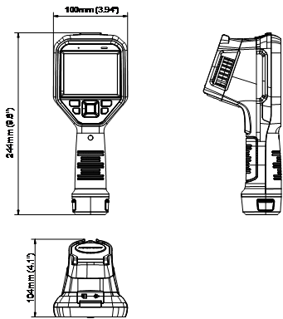

Unit: mm (inch)

- Optional Accessories
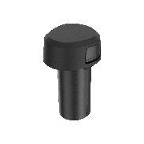 | 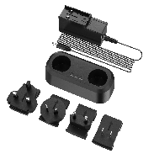 | 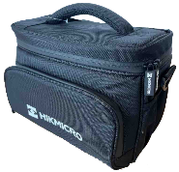 | 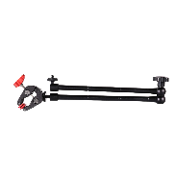
E097-13-1S1P26650 | HM-5202ZC | HM-SP01-POUCH | HM-2925ZJ-TM01-BRACKET

COMPLIANCE NOTICE: The thermal series products might be subject to export controls in various countries or regions, including without limitation, the United States, European Union, United Kingdom and/or other member countries of the Wassenaar Arrangement. Please consult your professional legal or compliance expert or local government authorities for any necessary export license requirements if you intend to transfer, export, re-export the thermal series products between different countries.

