Mini3
Smartphone Module

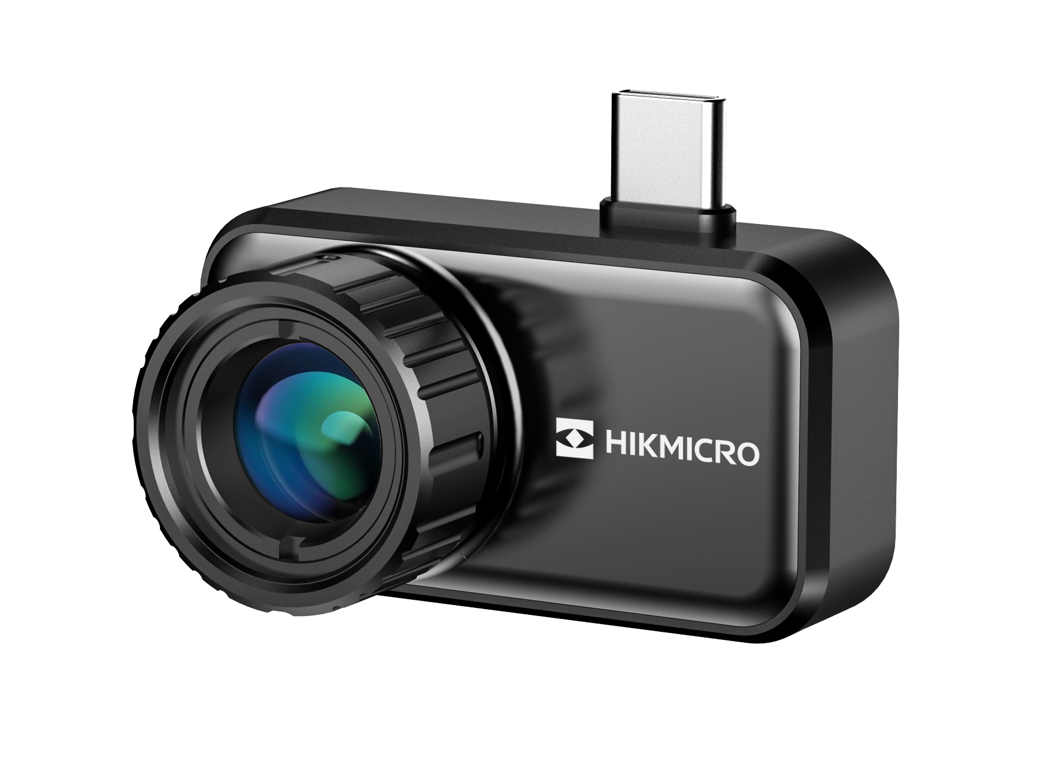
The Smartphone Module is designed to inspect electrical equipment, troubleshooting HVAC problems. Equipped with functional thermal App for smartphone, the Smartphone Module enables you to get the thermal imaging on your phone.

Key Features

- Thermal resolution: 384× 288 (110,592 pixels)
- NETD: ≤ 30 mK (@ 25 °C, F#=1.0)
- Accuracy: ±2 ℃ (-20 °C to 100 °C) ; ±2 % (100 °C to 650 °C)
- USB Type-C Interface (Android)
- 45 g Weight

Specification
Infrared Image
IR Resolution | 384× 288 (110,592 pixels)
NETD | ≤30 mK (@ 25 °C, F#=1.0)
Image Frequency | 25Hz/50Hz
Detector Pitch | 12μm
Spectral Range | 7.5 to 14 μm
Focal Length | 10mm
F-number | F1.0
Field of View (FOV) | 26° × 19°
Min. Focus Distance | 0.3 m (0.98 ft)
Focus Mode | Manual Focus
Image Display
Color Palettes | White Hot, Black Hot, Rainbow, Ironbow, Sepia, Color, Ice Fire, Rain, Red Hot, Green Hot, Dark Blue, Combined
Image Modes | Thermal
Measurement and Analysis
Object Temperature Range | -20°C to 650°C(-4°F to 1202°F )
Accuracy | Max (±2°C/3.6°F, ±2%), for ambient temperature 15°C to 35°C (59°F to 95°F) and object temperature above 0°C (32°F)
Measurement Tools | Center Spot, Hot Spot, Cold Spot  User-definable: 3 spots, and 3 rectangles.
Level and Span Mode | Auto/Manual
General
Power Consumption | 550 mW
Interface | USB-C
Protection Level | IP40
Drop Test Height | 1 m (3.28 ft)
Working Temperature Range | -10°C to 50°C (14°F to 122°F )
Storage Temperature Range | -20°C to 60°C (-4°F to 140°F )
Weight | Approx. 45 g (0.099 lb)
Dimension | 47.6 × 26 × 26.59 mm (1.87 × 1.02 × 1.05 in)

- Available Model
HM-TJ33-10RF-Mini3

- Dimension
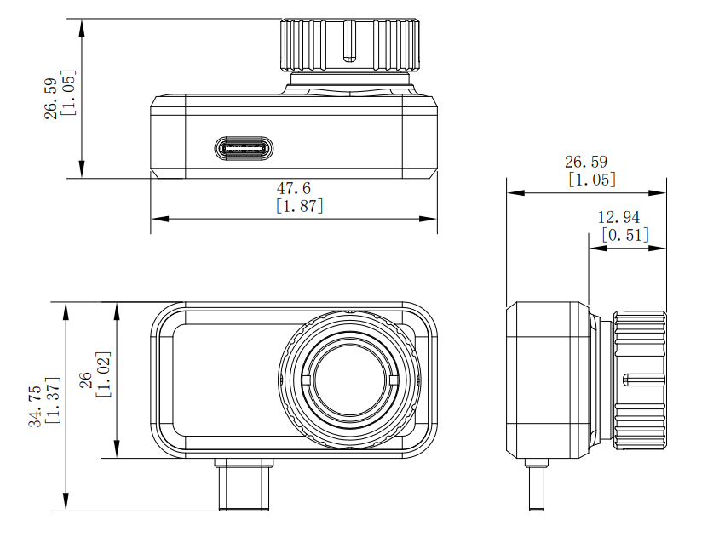
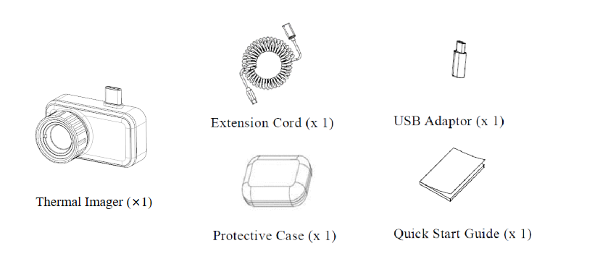

COMPLIANCE NOTICE: The thermal series products might be subject to export controls in various countries or regions, including without limitation, the United States, European Union, United Kingdom and/or other member countries of the Wassenaar Arrangement. Please consult your professional legal or compliance expert or local government authorities for any necessary export license requirements if you intend to transfer, export, re-export the thermal series products between different countries.

