PocketE
Pocket Thermal Camera

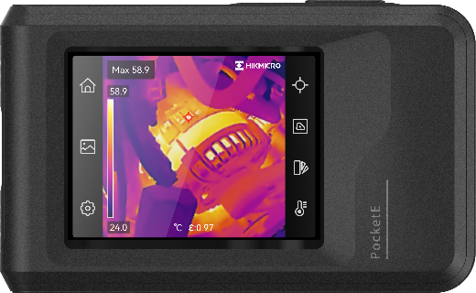

HIKMICRO Pocket Series has a high-resolution HIKMICRO VOx detector, an 0.3 MP optical camera, and a 3.5” LCD touch screen. It helps you quickly and efficiently locate hidden problems and accurately measure abnormal temperatures. The wide temperature range of -20°C to 350°C is ideal for building inspection, HVAC, electrical, and mechanical equipment maintenance. The 25 Hz frame rate keeps up with fast inspection, and the Wi-Fi function allows the Pocket to share images in real-time. The Pocket Series is a powerful thermography tool in your pocket, so it is always there whenever you need it.

Key Feature
- Thermal resolution: 96 × 96 (9,216 pixels), NETD: < 50 mK (@ 25°C, F# = 1.0)
- SuperIR: 240 × 240 (57,600 pixels)
- Accurately measure temperature from -20°C to 350°C (-4°F to 662°F)
- 112 : 1 Distance to spot ratio (D : S)
- Accuracy: Max. (± 2°C/3.6°F, ± 2%)
- 25 Hz image frequency
- Thermal, Fusion, PIP, and Visual modes
- Manual, automatic, and 1-Tap level and span
- High temperature alarm
- Built-in 4 GB memory
- LED work light
- 1.0× to 4.0× continuous digital zoom
- 0.3 MP visual camera
- Up to 4 hours continuous running

Specification
Infrared Image
IR Resolution | 96 × 96 (9,216 pixels)
SuperIR | 240 × 240 (57,600 pixels)
Distance to Spot Ratio (D : S) | 112 : 1
NETD | < 50 mK (@ 25°C, F# = 1.0)
Image Frequency | 25 Hz
Detector Pitch | 12 μm
Spectral Range | 7.5 μm to 14 μm
Focal Length | 1.35 mm
F-number | F1.0
Field of View (FOV) | 50° × 50°
Spatial Resolution (IFOV) | 8.89 mrad
Min. Focus Distance | 0.1 m (0.33 ft)
Focus Mode | Focus Free
Image Display
Visual Camera | 640 × 480 (0.3 MP)
Display | 320 × 240 Resolution, 3.5" LCD Touch Screen
Screen Brightness | Manual
Digital Zoom | 1.0× to 4.0× continuous
Color Palettes | White Hot, Black Hot, Rainbow, Ironbow, Red Hot, Fusion, Rain, Blue Red
Image Modes | Thermal/Visual/Fusion/PIP/Blending
Measurement and Analysis
Object Temperature Range | -20°C to 350°C (-4°F to 662°F )
Accuracy | Max. (± 2°C/3.6°F, ± 2%), for the ambient temp. 15°C to 35°C (59°F to 95°F) and object temp. above 0°C (32°F)
Measurement Tools | Center Spot, Hot Spot, Cold Spot
Level and Span Mode | Auto/Manual/1-Tap Touch-screen
Data Storage and Communication
Storage Media | Built-in 4 GB flash memory
Image Storage Capacity | Approx. 30,000 Images
Annotations | Voice note: max. 60 seconds;  Text note: max. 200 characters
Video Storage Capacity | Approx. 20 hours
Video File Format | MP4 video
General
Wi-Fi | 802.11 b/g/n (2.4 GHz)
USB Interface | USB Type-C
LED Light | Yes
Battery Type | Rechargeable Li-ion battery
Battery Operating Time | Approx. 4 hours
Battery Charging Time | Approx. 2.5 hours fully charged
Protection Level | IP54
Drop Test Height | 2 m (6.56 ft)
Working Temperature Range | -10°C to 50°C (-4°F to 122°F)
Storage Temperature Range | -20°C to 60°C (-4°F to 140°F)
Relative Humidity | < 95% non-condensing
Weight | Approx. 218 g (0.481 lb)
Dimension | 138.45 mm × 85.2 mm × 23.6 mm (5.45" × 3.35" × 0.93")
Tripod Mounting | UNC ¼”-20

Available Model
PocketE

Dimension
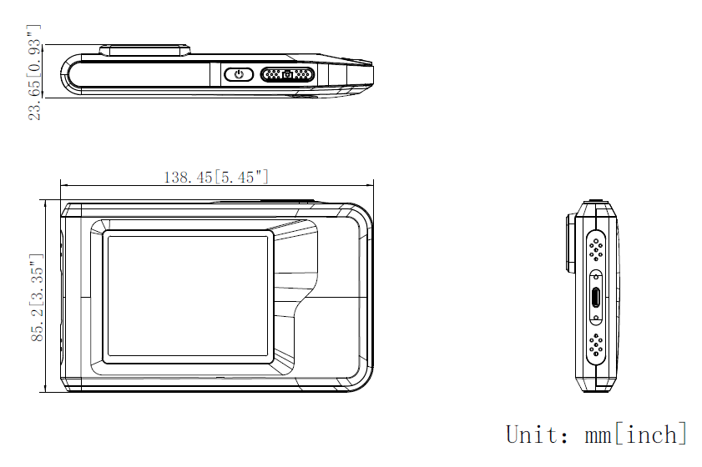

COMPLIANCE NOTICE: The thermal series products might be subject to export controls in various countries or regions, including without limitation, the United States, European Union, United Kingdom and/or other member countries of the Wassenaar Arrangement. Please consult your professional legal or compliance expert or local government authorities for any necessary export license requirements if you intend to transfer, export, re-export the thermal series products between different countries.

