SP120H
Handheld Thermal Camera

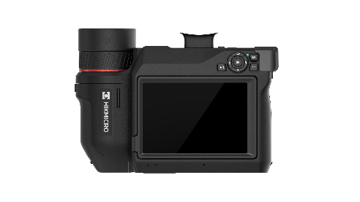

The HIKMICRO SP120H high-performance handheld thermal camera is an excellent choice for industrial, predictive, oil and gas, and utility maintenance inspections. It features a high-sensitivity HIKMICRO VOx detector (NETD < 20 mK) with a resolution of 1280 x 1024 and can measure temperatures up to 2200°C. This flexible and ergonomic thermal imager includes an electronic viewfinder and a 180° rotating lens, simplifying long outdoor inspections. Advanced features such as GPS and compass annotations, continuous digital zoom, and 1-Tap level and span make it easy for professionals to survey equipment and detect malfunctions. With the HIKMICRO Viewer App or HIKMICRO Analyzer software, users can transfer, analyze, and share images, as well as generate reports for free.

- Key Features
- Thermal resolution: 1280 x 1024 (1 310 720 pixels),NETD : ＜ 20 mK (@ 30 °C,F#=1.0)
- Temperature measurement range : -40°C to 2200°C (-40°F to 3992°F)
- Accuracy: Max. (± 2°C/3.6°F, ± 2%)
- The 90° rotating screen and the 180° rotating lens design
- 1024 x 768 OLED electronic viewfinder and auto-brightness 5.1-inch color LCD display
- 1.x to 12.x continuous digital zoom
- Manual, automatic, and 1-Tap Level and Span
- GPS ＆ compass annotation functions
- 30 Hz image frequency
- Up to 4 hours continuous running

- Specification
Infrared Image
IR Resolution | 1280 × 1024 (1,310,720 pixels)
SuperIR | 2560 × 2048 (5,242,880 pixels)
NETD | ＜20 mK (@ 30 °C, F#=1.0)
Image Frequency | 30 Hz
Detector Pitch | 12 μm
Spectral Range | 7.5 to 14 μm
Focal Length | L8: 112.2 mm  L12: 72.9 mm  L25: 35 mm  L50: 17.6 mm
F-number | L8: F1.3  L12: F1.2  L25: F1.1  L50: F1.1
Field of View (FOV) | L8: 7.9° × 6.3°  L12: 12° × 9.6°  L25: 25° × 20°  L50: 50° × 40°
Spatial Resolution (IFOV) | L8: 0.11 mrad  L12: 0.17 mrad  L25: 0.34 mrad  L50: 0.68 mrad
Min. Focus Distance | L8: 5m (16.4 ft)  L12: 1.65m (5.41 ft)  L25: 0.3m (0.98 ft)  L50: 0.2m (0.66 ft)
Focus Mode | Laser Assisted AF/Continuous AF/AF/Manual Focus/Touch AF
Focus Speed | Approx. 2 second
Image Display
Visual Camera | 4208 × 3120 (13 MP）
Display | 1920 × 1080 Resolution, 5.1” OLED Touch Screen, Lv 360 Cd/m^2
Screen Brightness | Manual/Auto
Viewfinder | 1024 × 768 pixels OLED
Digital Zoom | 1.x to 12.x continuous
Color Palettes | White Hot, Black Hot, Rainbow, Ironbow, Red Hot, Fusion, Rain, Blue Red
Focus Mode Palette | Above/Below/Interval
Color Alarm | Above/Below/Interval/Insulation/Condensation
Image Modes | Thermal/Visual/Fusion/PIP/Blending
Measurement and Analysis
Object Temperature Range | -40°C to 2200°C (-40°F to 3992°F)
Accuracy | Max. (± 2°C/3.6°F, ± 2%)
Measurement Tools | Center Spot, Hot Spot, Cold Spot  User-definable: Delta T, 10 spots, 1 line, 5 rectangles, and 5 circles
Level and Span Mode | Auto/Manual/1-Tap Touch-Screen
Inspection Route | Yes
Data Storage and Communication
Storage Media | Removable 128 GB SD Card
Image Storage Capacity | Approx. 30,000 Images
Annotations | Voice note: max. 60 seconds;  Text note: max. 200 characters
Video Storage Capacity | Approx. 130 Hours（MP4 video）
Video File Format | MP4 video  and radiometric video
Image Format | Radiometric JPEG
IR Live Streaming | Radiometric streaming via USB  Non-radiometric streaming via USB and Wi-Fi
General
Wi-Fi | 802.11 b/g/n (2.4 GHz and 5 GHz)
Bluetooth | Bluetooth 4.2
USB Interface | USB Type-C
HDMI Interface | HDMI-D
LED Light | Yes
Laser Pointer | Yes
Laser Distance Meter | Indoor distance: 50 m (164 ft);  Outdoor distance: 15 m (49 ft).
Laser | Yes, Class II, Wavelength: 635 nm; Power: < 1 mW
Battery Type | Interchangeable and rechargeable Li-ion battery
GPS & Compass | Yes
Battery Operating Time | Approx. 4 hours
Battery Charging Time | Approx. 2.5 hours fully charged
Power Saving Mode | Yes
Programmable Buttons | 2
Protection Level | IP54, IEC 60529
Drop Test Height | 1 m (3.28 ft), IEC 60068-2-31
Safety | IEC 61010-1
EMC | EN 301 489-1, EN 301 489-17, EN IEC 61000-6-2, EN IEC 61000-6-3, EN 61326-1
Vibration | 2 g, IEC 60068-2-6
Shock | 25 g, IEC 60068-2-27
Working Temperature Range | -20°C to 50°C ( -4°F to 122 °F)
Storage Temperature Range | -20°C to 60°C ( -4°F to 140°F)
Relative Humidity | ＜95% non-condensing
Weight | Approx. 1550 g (3.42 lb)（Without lens）
Dimension | 220.5 × 151.9 × 88.1 mm (8.68 × 5.98 × 3.47 in)（Without lens）
Tripod Mounting | UNC ¼”-20
Warranty | 3 years for the full product, 10 years for the detector, and 2 years for the battery.

- Available Model
HM-TP9CH-W/W-SP120H-L25

- Dimension
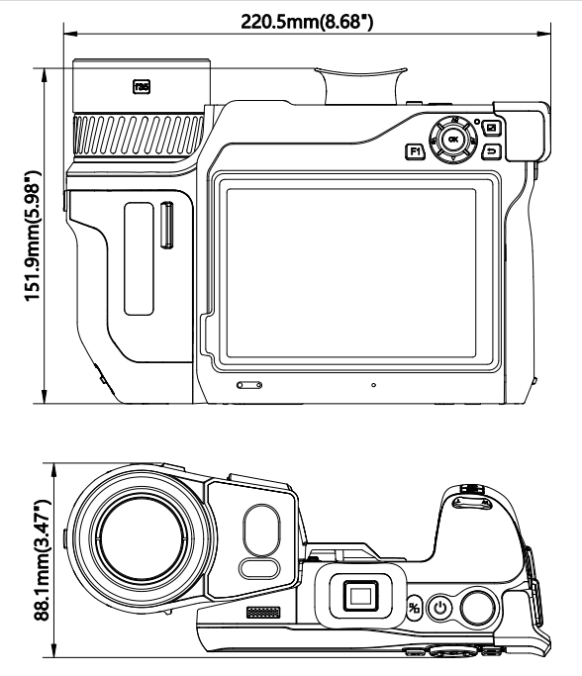

- Packaging
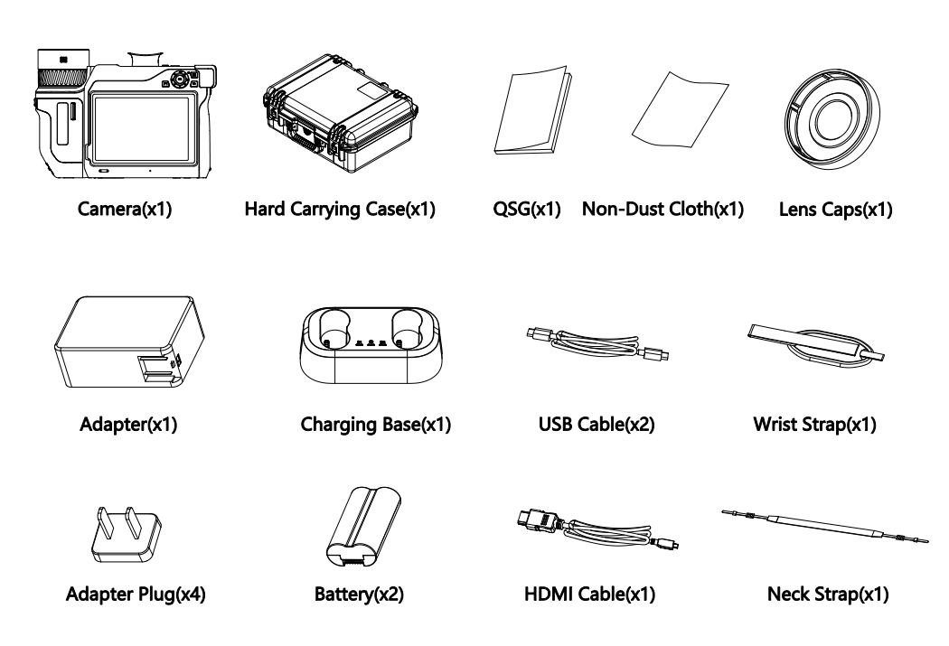

- Accessory
- Optional
HM-20322ZC  SP Series Battery Charger | HM-7250DC  SP Series Battery | HM-SP01-POUCH  M/G/SP Series Pouch
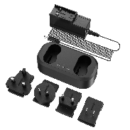 | 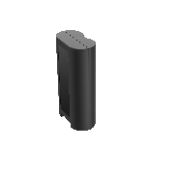 | 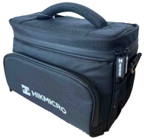

COMPLIANCE NOTICE: The thermal series products might be subject to export controls in various countries or regions, including without limitation, the United States, European Union, United Kingdom and/or other member countries of the Wassenaar Arrangement. Please consult your professional legal or compliance expert or local government authorities for any necessary export license requirements if you intend to transfer, export, re-export the thermal series products between different countries

