SP40H
Handheld Thermal Camera

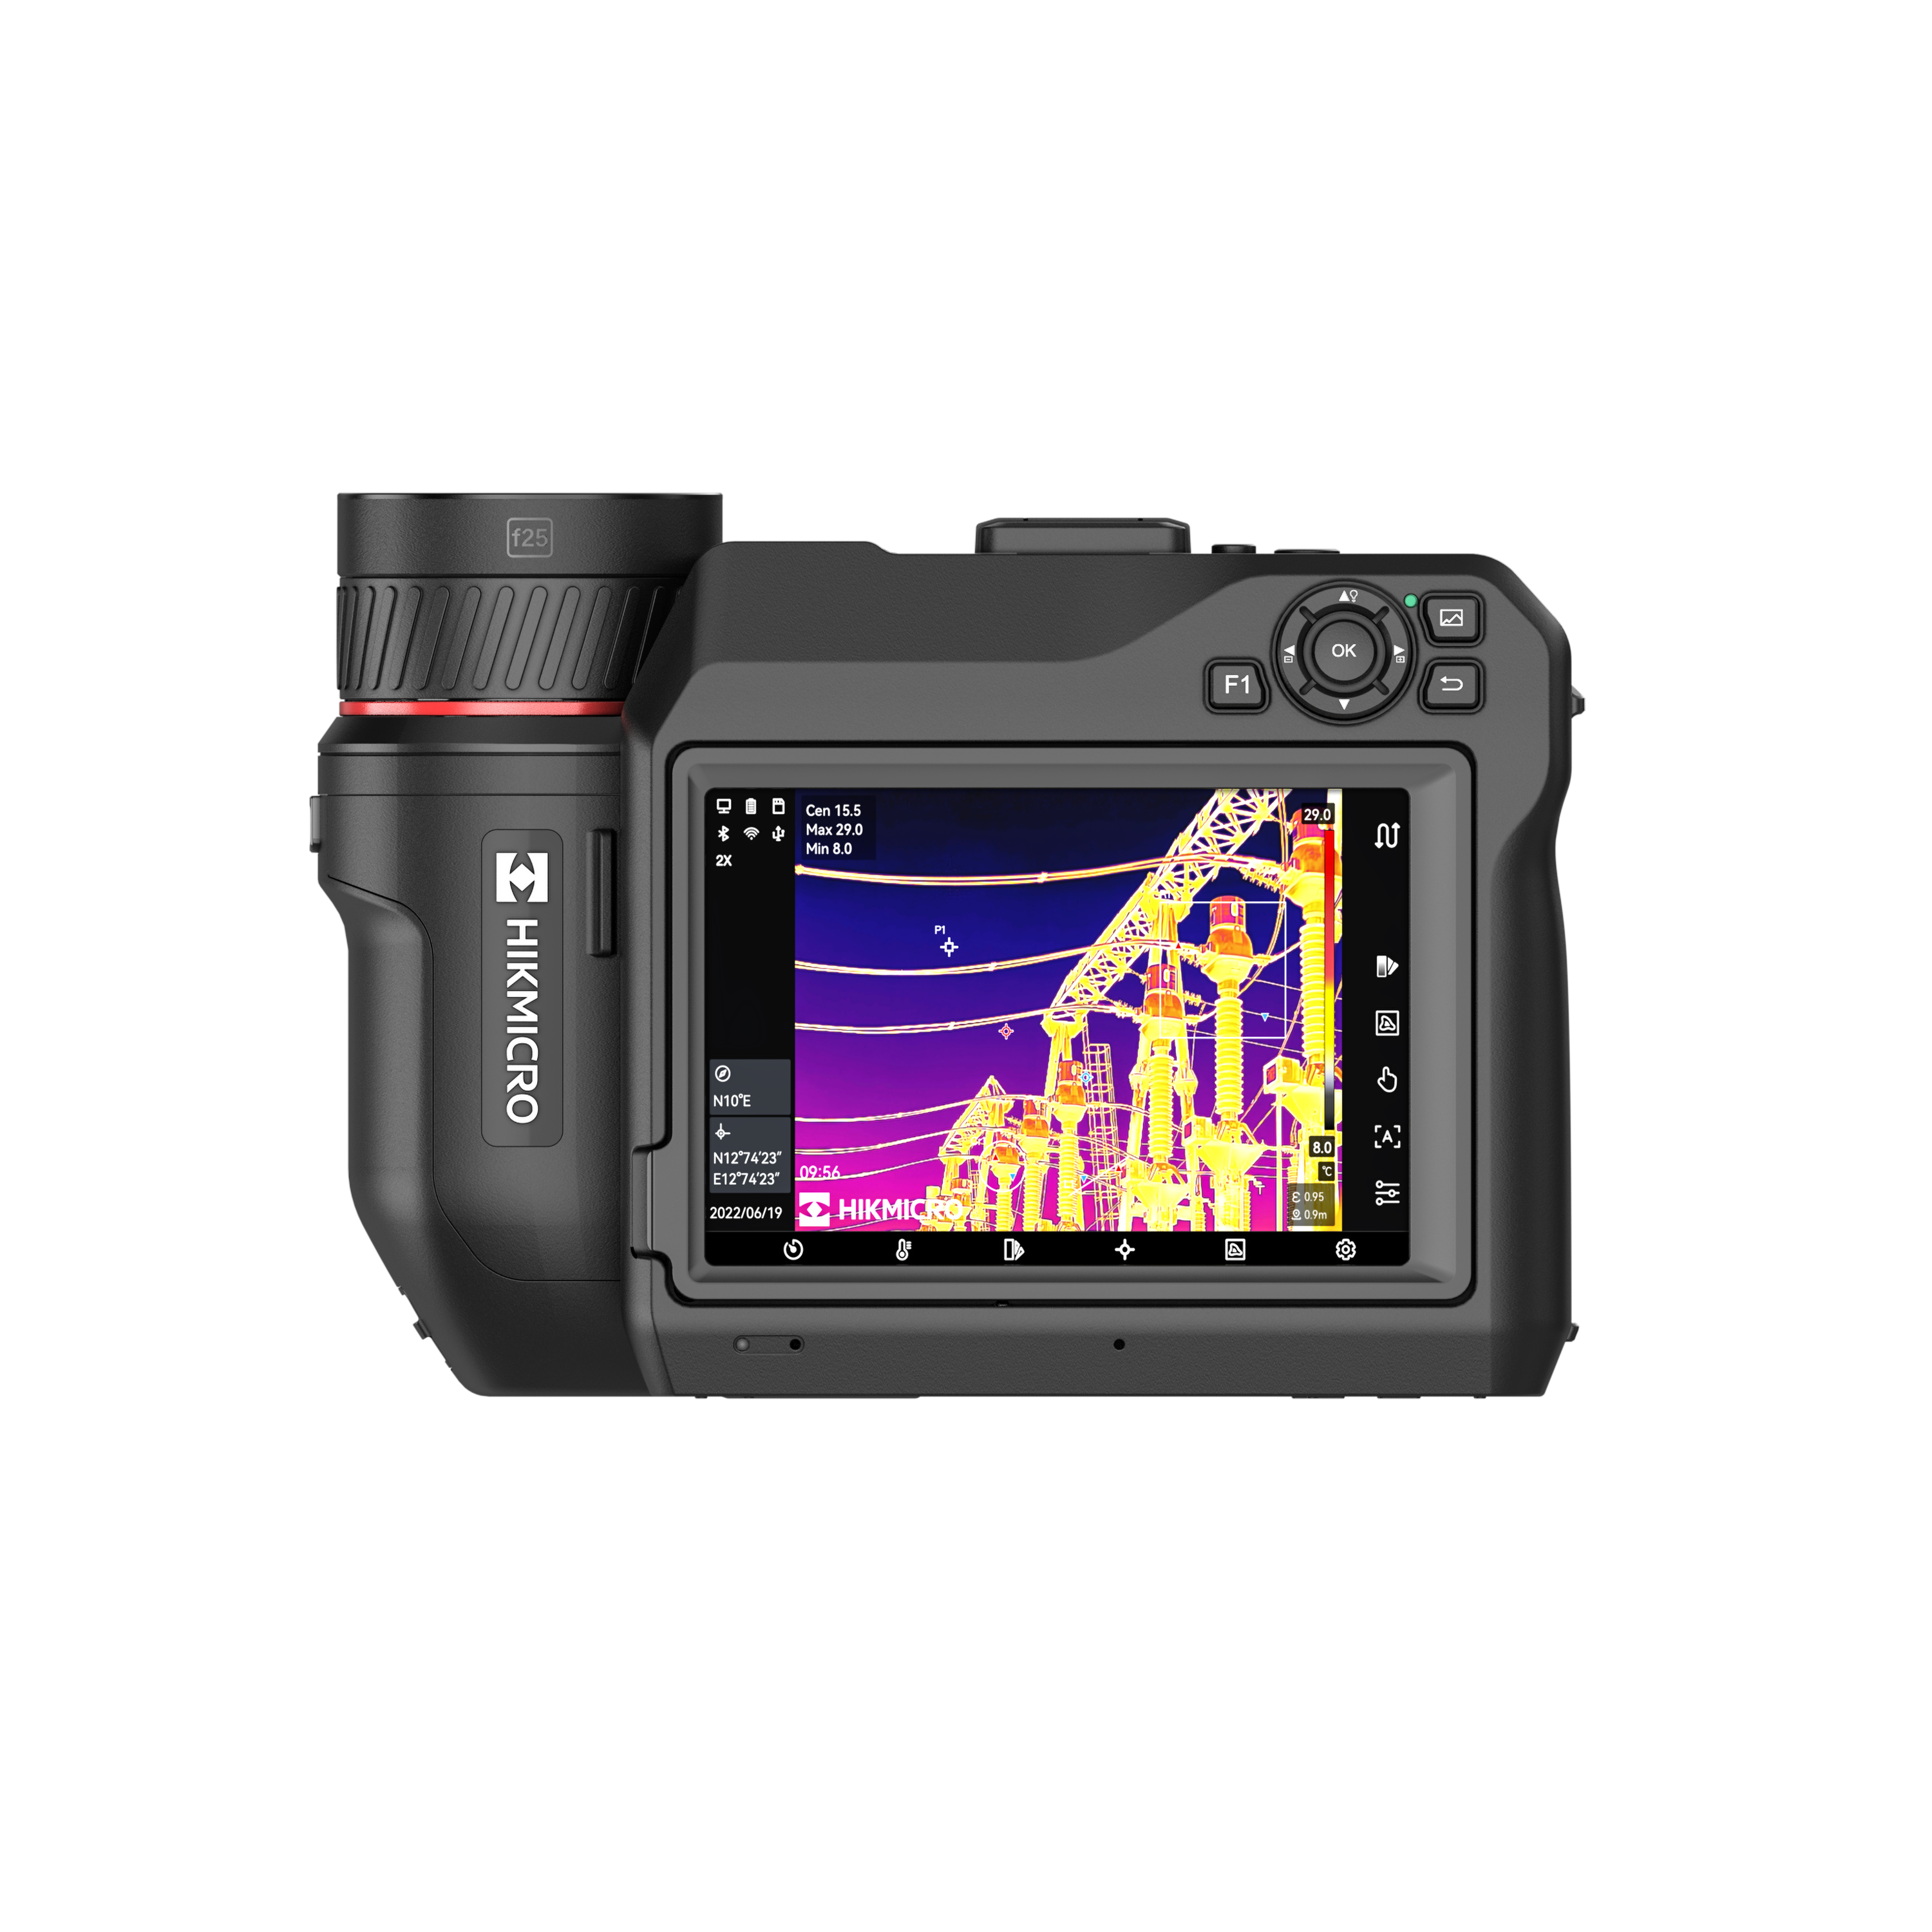

The HIKMICRO SP40H high-performance handheld thermal camera is ideal for industrial, predictive, oil and gas, and utility maintenance inspections. HIKMICRO SP40H has a high sensitivity (NETD < 30 mK) and high resolution (480 × 360) HIKMICRO VOx detector, and the temperature calibration is up to 2200°C. Advanced features help thermal imaging professionals to easily survey equipment and find signs of malfunction, such as GPS and compass annotations, continuous digital zoom, and 1-Tap level and span. Connect HIKMICRO Viewer App or HIKMICRO Analyzer software to transfer, analyze, and share pictures, and generate reports for free.
Key Features
- Thermal resolution: 480 × 360 (172,800 pixels),NETD : < 30 mK (@ 25 °C,F#=1.0)
- Temperature measurement range : -40°C to 2200°C (-40°F to 3992°F)
- Accuracy: Max. (±1°C (±1.8°F): 0 to 100°C (32 to 212°F); ±1%: 100 to 150°C (212 to 302°F))
- The 90° rotating screen and the 180° rotating lens design
- 1.x to 12.x continuous digital zoom
- Manual, automatic, and 1-Tap Level and Span
- 30 Hz image frequency
- Up to 4 hours continuous running

- Specification
Infrared Image
IR Resolution | 480 × 360 (172,800 pixels)
SuperIR | 960 x 720 (691,200 pixels)
NETD | < 30 mK (@ 25 °C, F#=1.0)
Image Frequency | 30 Hz
Spectral Range | 7.5 to 14 μm
Detector Pitch | 17 μm
F-number | L6: F1.2; L9: F1.1; L19: F1.0; L37: F1.0
Focal Length | L6: 77.4 mm; L9: 51.4 mm; L19: 25 mm; L37: 12.6 mm
Field of View (FOV) | L6: 6° × 4.5°; L9: 9° × 6.8°; L19: 18.7° × 14°; L37: 37.3° × 27.8°
Spatial Resolution (IFOV) | L6: 0.22 mrad; L9: 0.33 mrad; L19: 0.68 mrad; L37: 1.35 mrad
Min. Focus Distance | L6: 2 m (6.56 ft); L9: 1 m (3.3 ft); L19: 0.2 m (0.65 ft); L37: 0.2 m (0.65 ft)
Focus Mode | Laser Assisted AF/Continuous AF/AF/Manual Focus/Touch AF
Focus Speed | Approx. 1 second
Image Display
Visual Camera | 3264 × 2448 (8 MP)
Display | 1280 × 720 Resolution, 5” LCD Touch Screen
Screen Brightness | Manual/Auto
Digital Zoom | 1.x to 12.x continuous
Color Palettes | White Hot, Black Hot, Rainbow, Ironbow, Red Hot, Fusion, Rain, Blue Red
Focus Mode Palette | Above/Below/Interval
Color Alarm | Above/Below/Interval/Insulation
Image Modes | Thermal/Visual/Fusion/PIP/Blending
Measurement and Analysis
Object Temperature Range | -40°C to 2200°C (-40°F to 3992°F)
Accuracy | ±1°C (±1.8°F): 0 to 100°C (32 to 212°F); ±1%: 100 to 150°C (212 to 302°F); ±2°C (±3.6°F): -40 to 0°C (-40 to 32°F); ±2%: 150 to 2200°C (302 to 3992°F)
Measurement Tools | Center Spot, Hot Spot, Cold Spot  User-definable: Delta T, 10 spots, 1 line, 5 rectangles, and 5 circles
Level and Span Mode | Auto/Manual/1-Tap Touch-Screen
Inspection Route | Yes
Data Storage and Communication
Storage Media | Removable 64 GB SD Card
Image Storage Capacity | Approx. 60,000 Images
Annotations | Voice note: max. 60 seconds;  Text note: max. 200 characters
Video Storage Capacity | Approx. 64 hours
Video File Format | MP4 video and radiometric video
Image Format | Radiometric JPEG
Radiometric Infrared-Video Streaming (Compressed) | Over UVC, Wi-Fi
General
Wi-Fi | 802.11 b/g/n (2.4 GHz and 5 GHz)
Bluetooth | Bluetooth 4.2
USB Interface | USB Type-C
HDMI Interface | HDMI-D
Laser Pointer | Yes
Laser | Yes, Class II, Wavelength: 635 nm; Power: <1 mW
Laser Distance Meter | Indoor distance: 50 m (164 ft);  Outdoor distance: 10 m (33 ft).
GPS ＆ Compass | Yes
Battery Type | Interchangeable and rechargeable Li-ion battery
Battery Operating Time | Approx. 4 hours
Battery Charging Time | Approx. 2.5 hours fully charged
Power Saving Mode | Yes
Programmable Buttons | 2
Protection Level | IP54, IEC 60529
Drop Test Height | 1 m (3.28 ft), IEC 60068-2-31
Safety | IEC 61010-1
EMC | EN 301 489-1, EN 301 489-17, EN IEC 61000-6-2, EN IEC 61000-6-4, EN 61326-1
Vibration | 2 g, IEC 60068-2-6
Shock | 25 g, IEC 60068-2-27
Working Temperature Range | -20°C to 50°C ( -4°F to 122 °F)
Storage Temperature Range | -20°C to 60°C ( -4°F to 140°F)
Relative Humidity | < 95% non-condensing
Weight | Approx. 1451 g (3.2 lb)
Dimension | 204.7 × 141.03 × 87.8 mm (8.06 × 5.55 × 3.45 in)
Tripod Mounting | UNC ¼”-20
LED Light | Yes

- Available Model
HM-TP94H-Q/W-SP40H-L9
HM-TP94H-Q/W-SP40H-L37
HM-TP94H-Q/W-SP40H-L19
HM-TP94H-Q/W-SP40H-L6

- Dimension
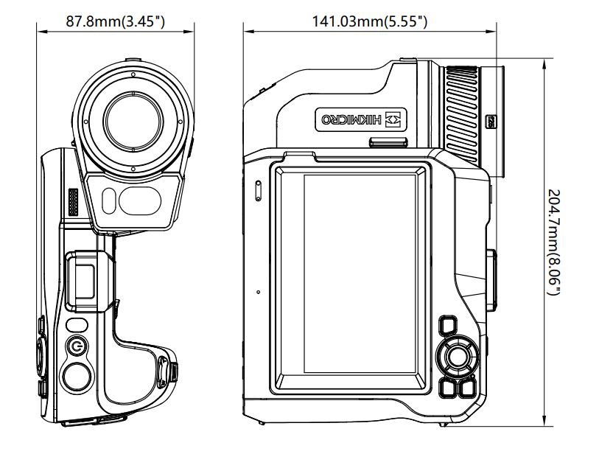

- Optional Accessory
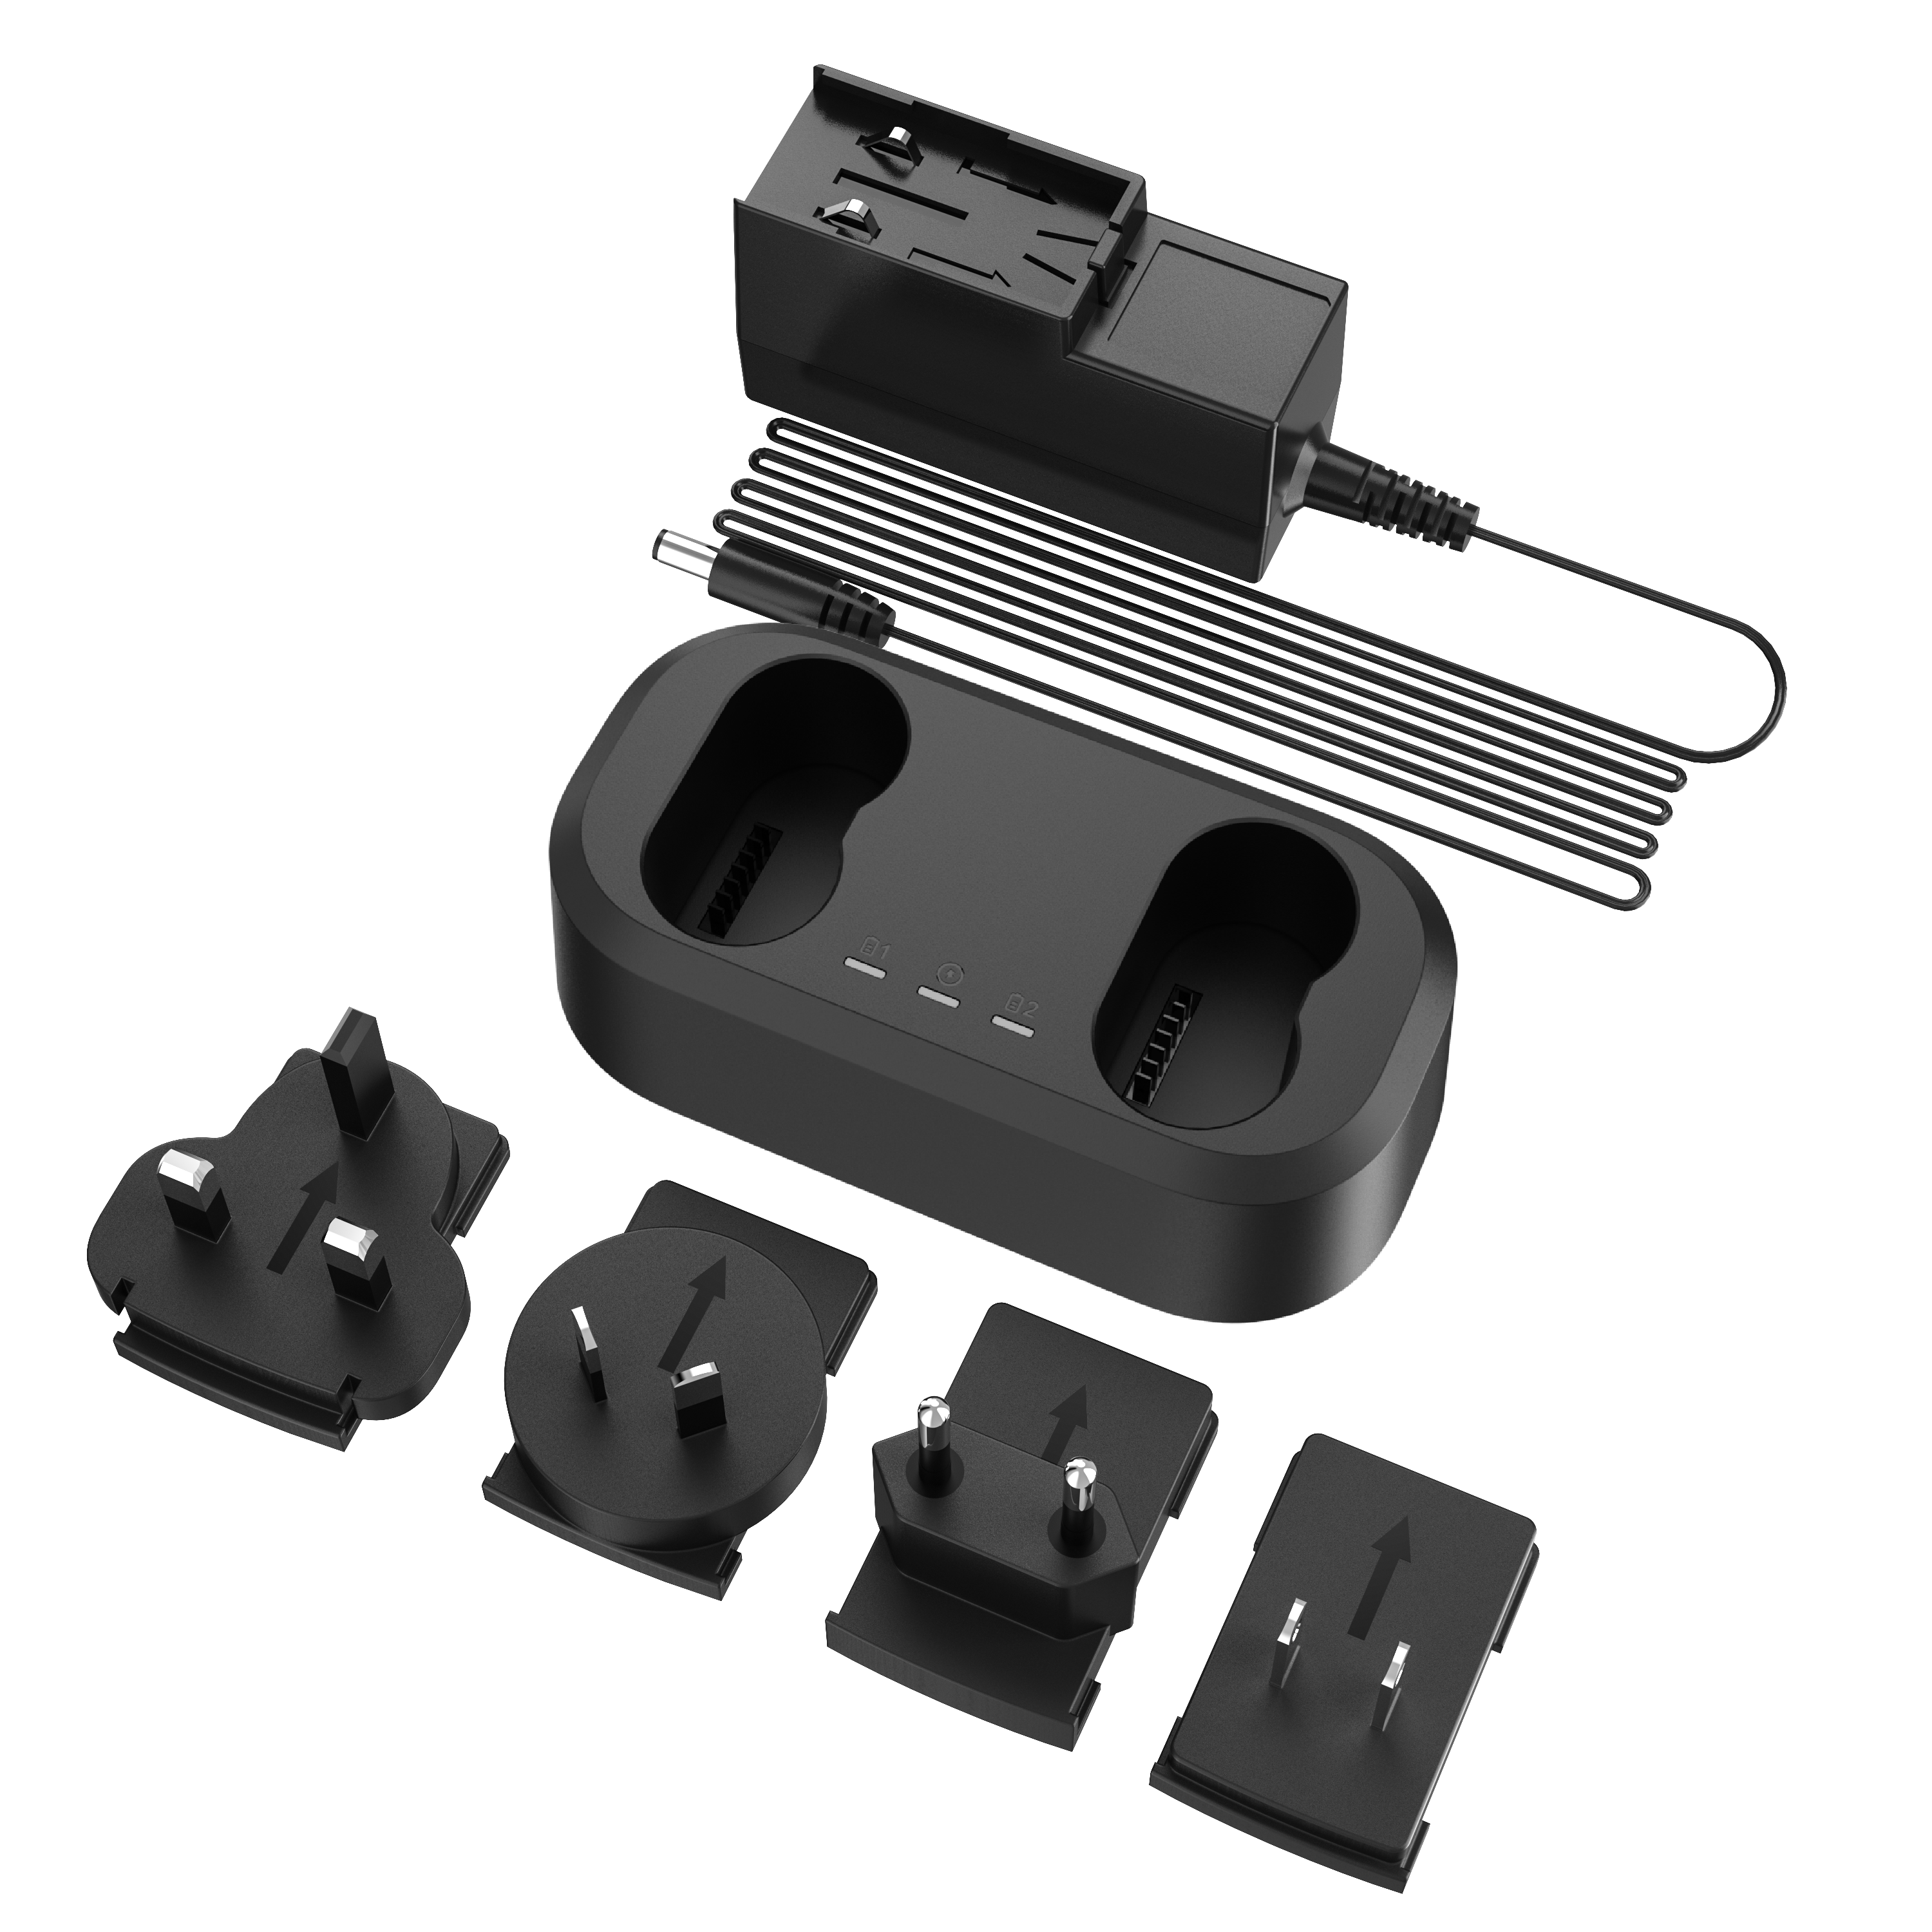 | 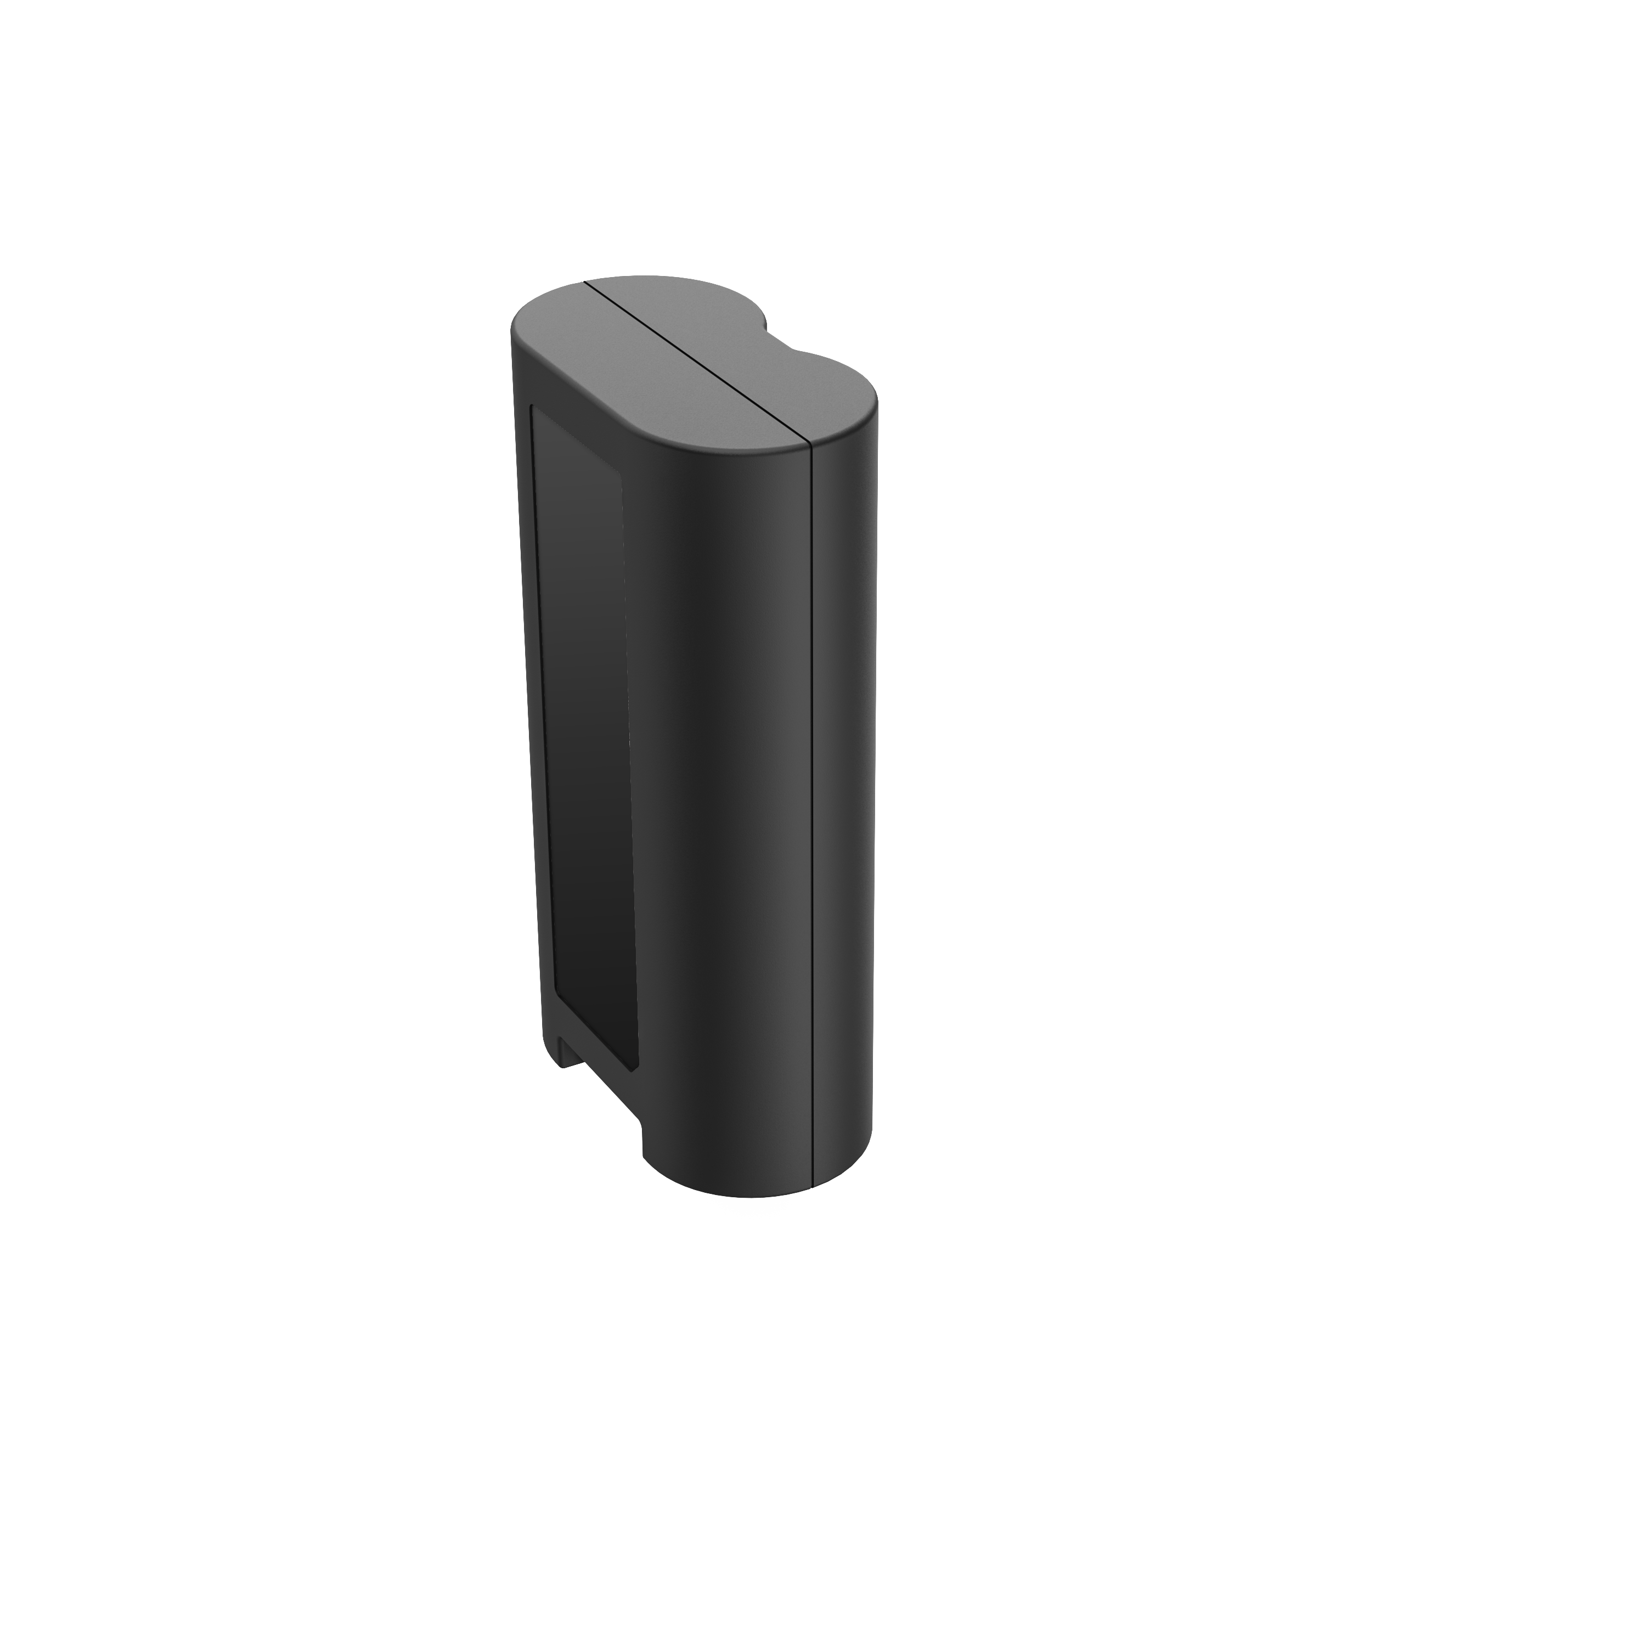 |  | 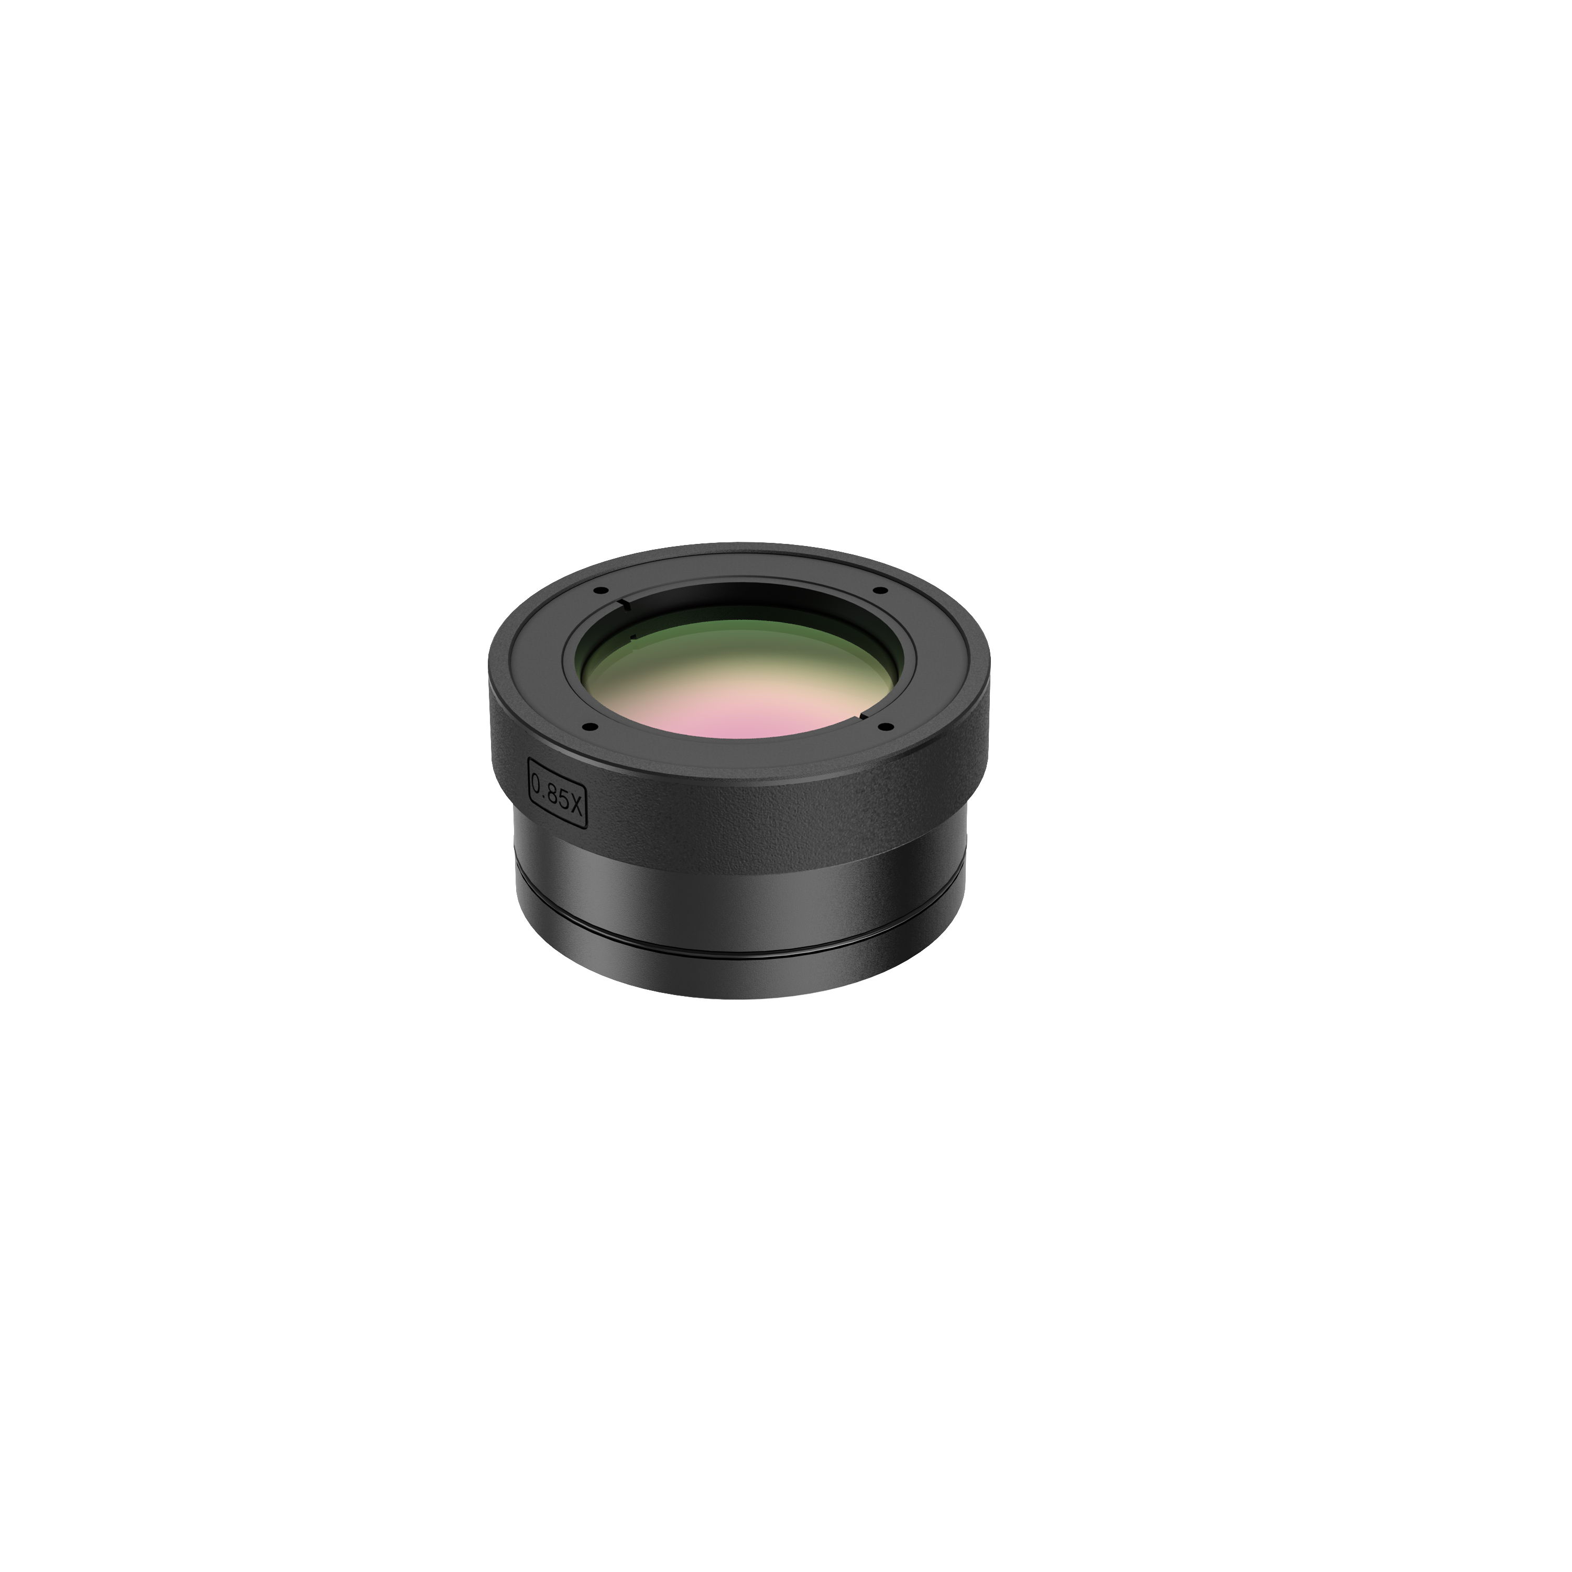 |  | 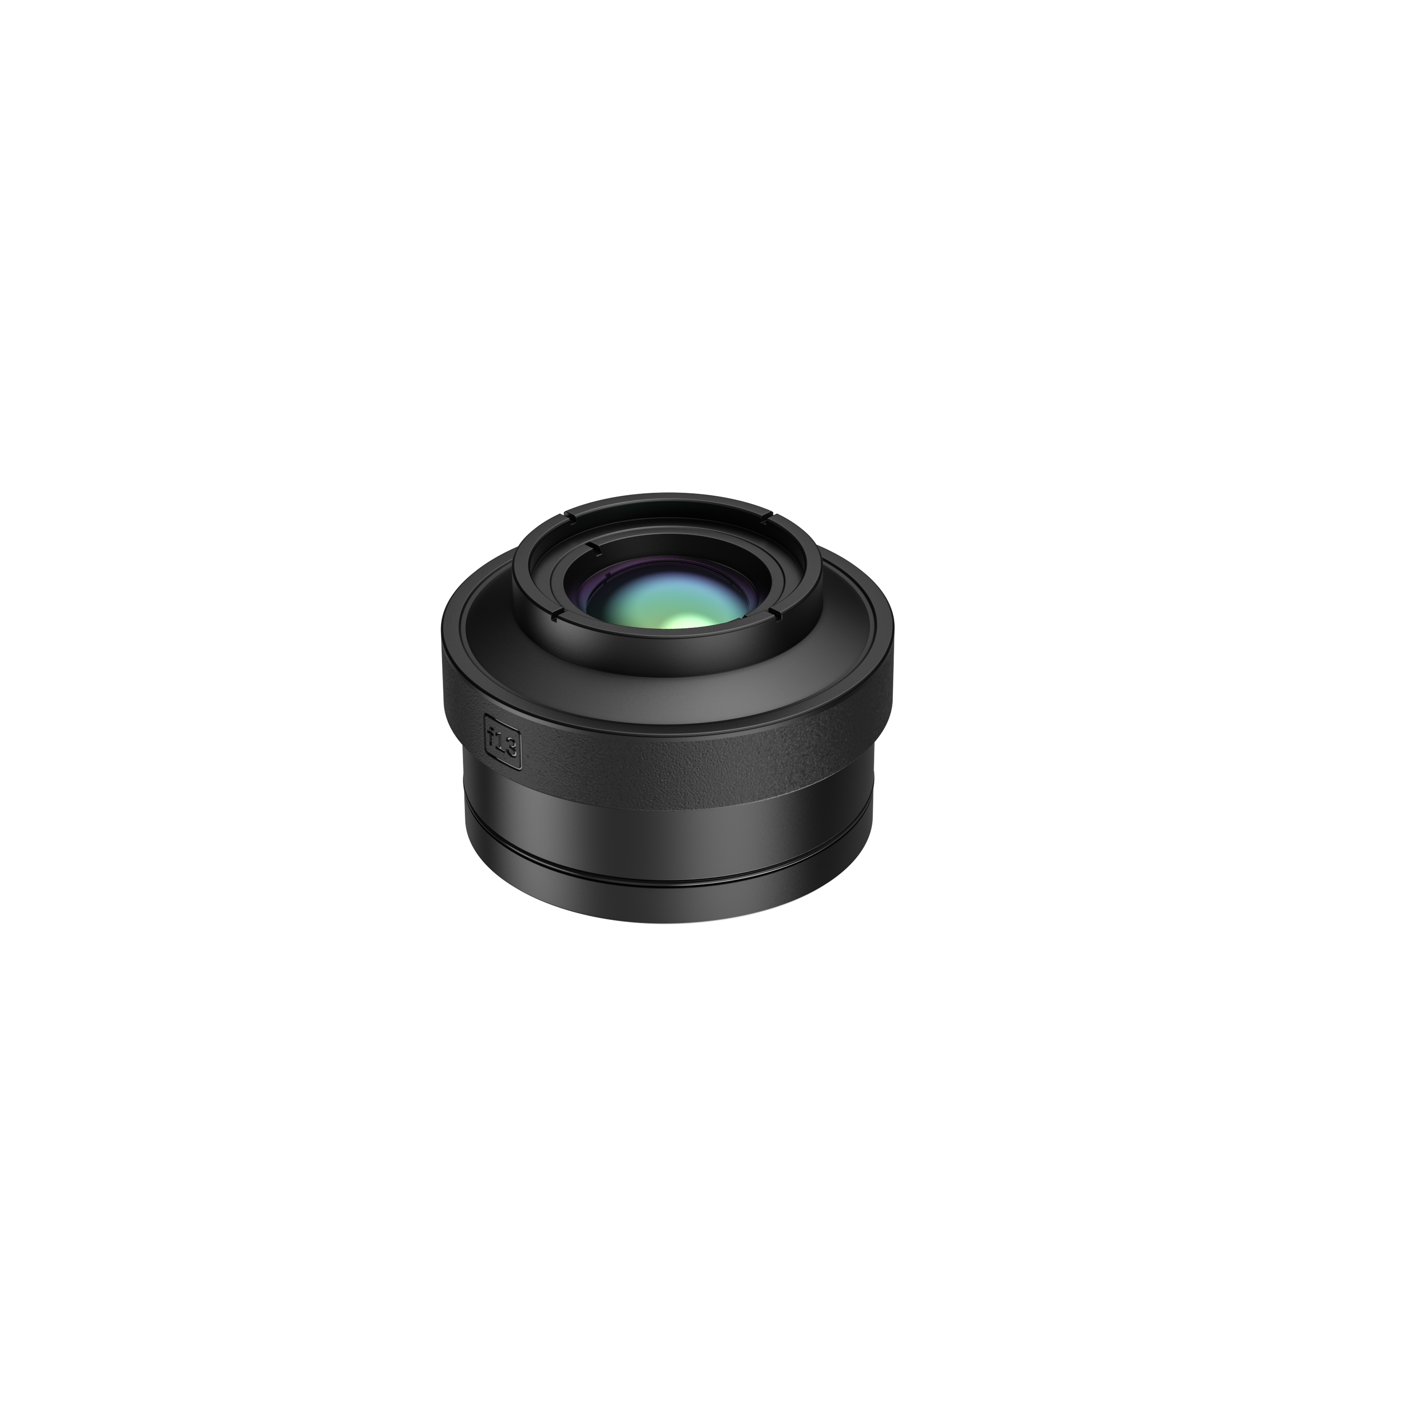 |  | 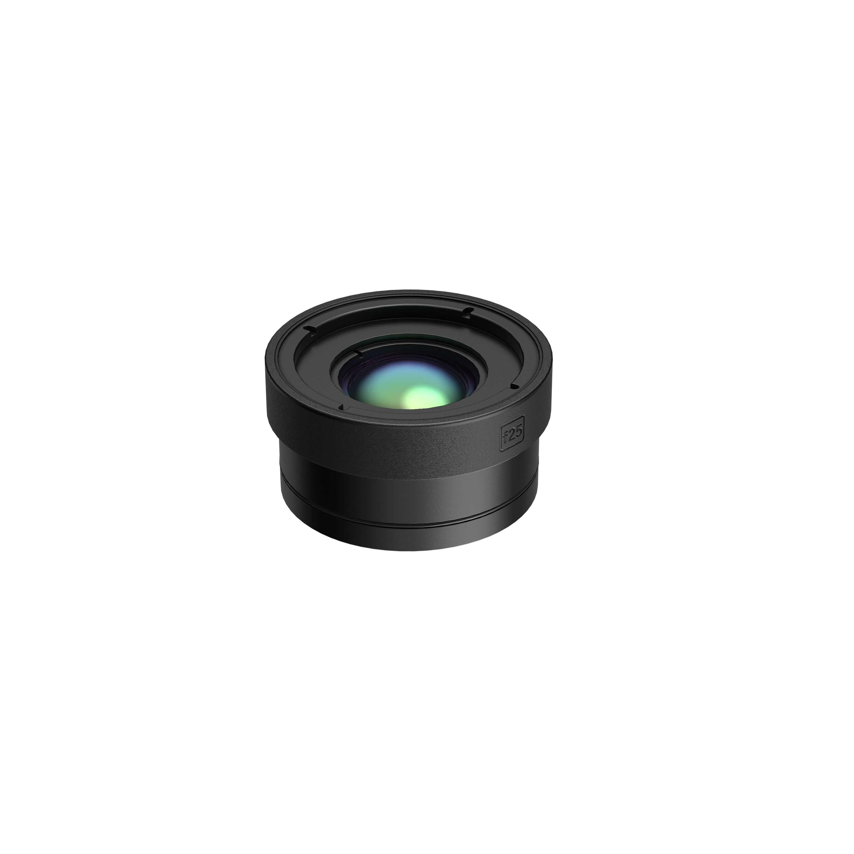
HM-20322ZC | HM-7250DC |  | HM-SP620-MACRO |  | HM-SP605-LENS |  | HM-SP610-LENS
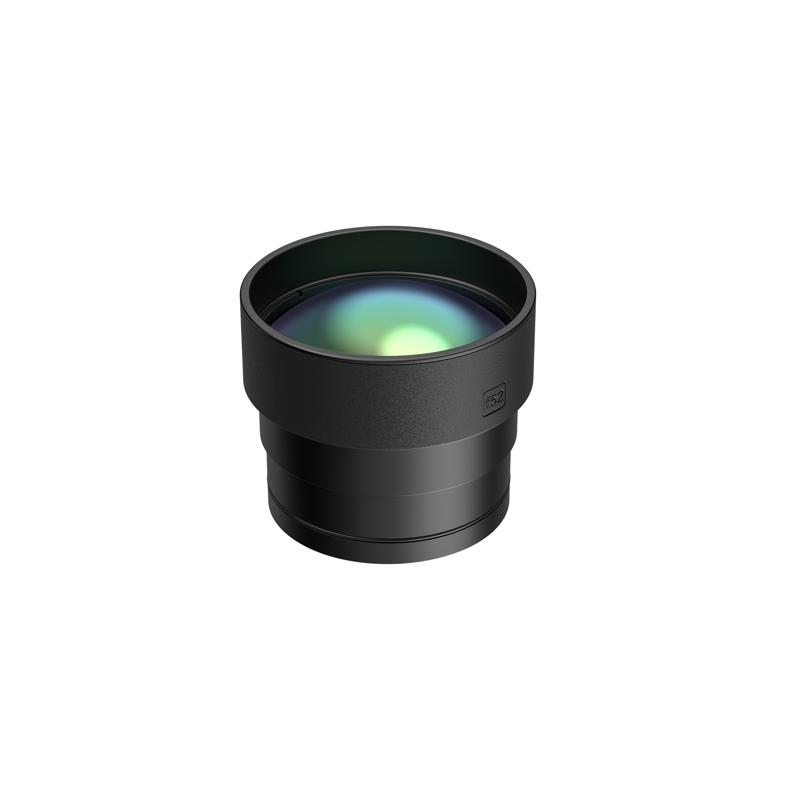 |  | 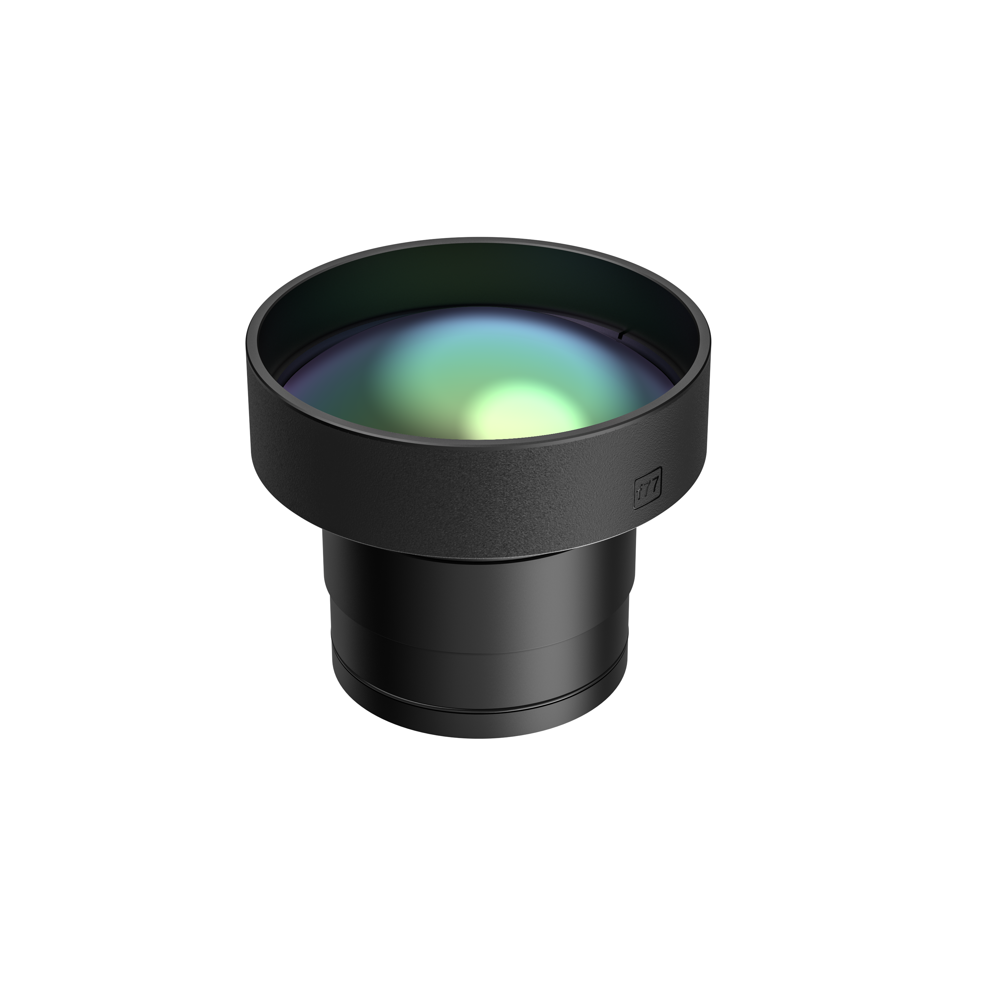 |  | 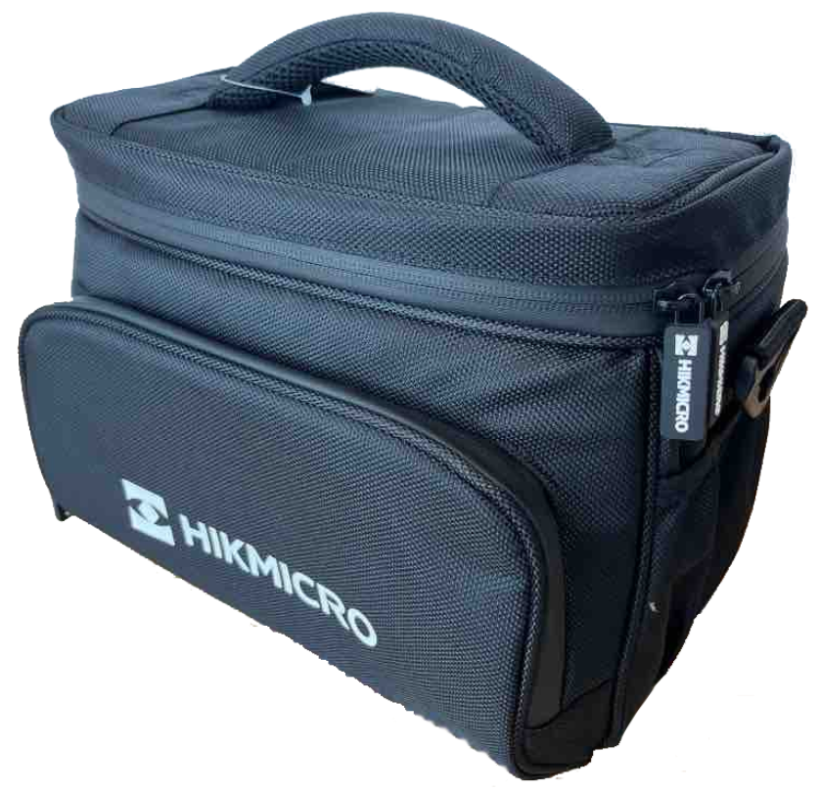 |  | 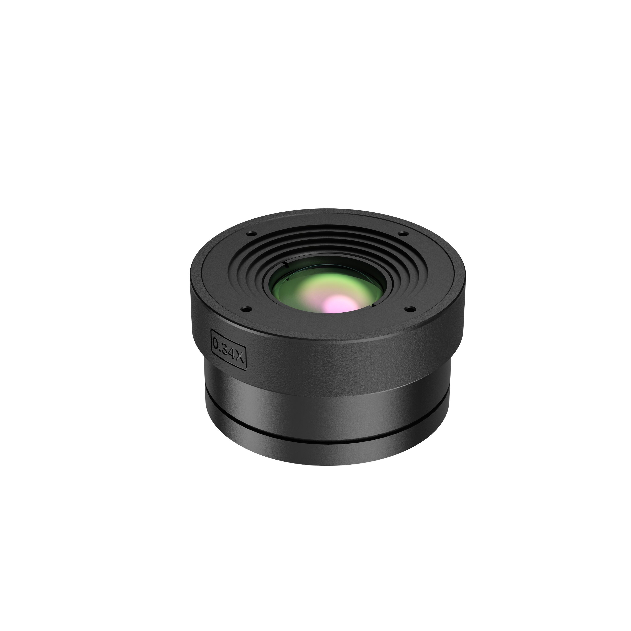
HM-SP620-LENS |  | HM-SP630-LENS |  | HM-SP01-POUCH |  | HM-SP650-MACRO

COMPLIANCE NOTICE: The thermal series products might be subject to export controls in various countries or regions, including without limitation, the United States, European Union, United Kingdom and/or other member countries of the Wassenaar Arrangement. Please consult your professional legal or compliance expert or local government authorities for any necessary export license requirements if you intend to transfer, export, re-export the thermal series products between different countries.

